FCIS Damietta University

 

**Furniture Online Store**

**Prepared By:**

**1. Eslam saber Elfar**

**2. Ahmed Khaled Elsharabasy**

**3. Mazen Hassan Elalfy**

**4. Mohammed Ahmed Nasr**

**5. Rowida Mohammed Abdelaal**

**6. Omnia Azmy Elqzaaz**

**7. Shrouk Sheriff Elsweesy**

**8. Sama Maged Rizk**

**Supervised by: DR\ Amira sedeek Elzeiny**

**2022/2023**

**Abstract:**

The world of commerce has transformed significantly in the past few decades with the introduction of E-commerce. E-commerce, or electronic commerce, refers to the buying and selling of goods and services through the internet. The emergence of E-commerce has transformed the traditional brick-and-mortar retail industry, making it more accessible, efficient, and convenient for consumers worldwide. One area where E-commerce has particularly flourished is the furniture industry, with the rise of multivendor E-commerce platforms for furniture. In this abstract, we will explore the impact of E-commerce on the furniture industry and the rise of multivendor E-commerce platforms.

E-commerce has revolutionized the furniture industry, making it more accessible and convenient for consumers to purchase furniture online. The convenience of online shopping allows consumers to browse through various options and compare prices from the comfort of their homes. Additionally, E-commerce has eliminated the geographical barriers for consumers, allowing them to purchase furniture from anywhere in the world. This has increased competition among furniture retailers, leading to more competitive prices and greater choices for consumers.

The rise of multivendor E-commerce platforms in the furniture industry has further transformed the industry. Multivendor E-commerce platforms are online marketplaces where multiple vendors can sell their products under one platform. These platforms allow vendors to access a wider audience and gain more exposure, while consumers can access a variety of products from different vendors. The benefits of multivendor E-commerce platforms are numerous, including greater product variety, competitive prices, and improved customer service. Moreover, the ease of setting up an online store on a multivendor platform has made it more accessible for small and medium-sized businesses to enter the furniture industry.

Despite the benefits, multivendor E-commerce platforms face several challenges. The first challenge is maintaining quality control across different vendors. With multiple vendors selling products on the same platform, it can be challenging to ensure consistent quality across all products. Another challenge is maintaining customer trust and loyalty. As multivendor platforms host multiple vendors, it is essential to ensure that vendors adhere to ethical business practices and provide high-quality products and services.

In conclusion, E-commerce has transformed the furniture industry, making it more accessible, efficient, and convenient for consumers worldwide. The rise of multivendor E-commerce platforms has further revolutionized the industry, providing greater product variety and competitive prices for consumers. However, multivendor E-commerce platforms also face several challenges, such as maintaining quality control and ensuring customer trust and loyalty. Overall, the emergence of E-commerce and multivendor platforms in the furniture industry has been a game-changer, providing consumers with more choices and opportunities to purchase high-quality furniture online.

**Acknowledgment:**

First and foremost, we owe a special dept of gratitude to our supervisor who graciously provided use with her experience and helping shape and direct our interest into a more focused and defensible work and without her this work would not have been possible. So, we would like to express our special thanks and deepest gratitude to **DR\ Amira sedeek Elzeiny.**

We would also thank each of whom brought their individual expertise and knowledge to bear and had an active role in shaping the final product, without naming all of them, we would like to single out for praise **DR\ Reda Elbarogy.**

We would like to thank our friends and family whose love and support sustained us throughout the project. This project spanned several months and required a great deal of time and energy.

Finally, we had a great time in the Faculty of Computer and Information Sciences, we learned many things, and now it’s the time to use what we had learnt to produce the best of ours.

**Table of Contents:**

❖ Abstract .......................................................................................................................................2

❖ Acknowledgment ........................................................................................................................4

❖ Table of Contents ........................................................................................................................5

❖ List of Figures ............................................................................................................................8

❖ List of Tables ..............................................................................................................................8

❖ List of Abbreviations ..................................................................................................................9

❖ CHAPTER 1 (Introduction) .....................................................................................................13

1.1. Overview/Background Section ..............................................................................................14

1.2. Motivations and Problem Statement Section .........................................................................15

1.3. Objectives Section .................................................................................................................17

1.4. Contributions Section .............................................................................................................17

1.5. Project Outlines Section .........................................................................................................18

1.6. Project Timeline .....................................................................................................................18

❖ CHAPTER 2 (Literature Review) ............................................................................................14

2.1. Similar existing systems ........................................................................................................14

2.2. Core elements .........................................................................................................................15

❖ CHAPTER 3 (System Analysis) ...............................................................................................19

3.1 System Requirements ..............................................................................................................36

3.2 System Architecture ................................................................................................................39

3.3 System tools and technologies ................................................................................................39

❖ CHAPTER 4 (System Design) .................................................................................................19

4.1 Physical ERD ..........................................................................................................................36

4.2 System Logo ...........................................................................................................................39

4.3 UIUX .......................................................................................................................................39

❖ CHAPTER 5 (System Implementation) ...................................................................................19

5.1 Interface Design of the website ...............................................................................................36

5.2 Interface Design of the mobile application .............................................................................36

❖ CHAPTER 5 (Conclusion & Future Work) ..............................................................................19

❖ Appendix

❖ References

**List of Figures:**

Figure 3.2.1 Context diagram of the whole system. 23

Figure 3.2.2 Data Flow Diagram of the system. 24

Figure 3.2.3 Use Case Diagram of the system. 25

Figure 3.2.4 Entity-relationship diagram of the system. 32

Figure 3.2.5 Login structure chart. 36

Figure 3.2.6 Reset password structure chart. 36

Figure 3.2.7 Enter information structure chart. 37

Figure 3.2.8 Control account structure chart. 37

Figure 3.2.9 Complaints structure chart. 37

Figure 3.2.10 Add to cart structure chart. 38

Figure 3.2.11 Payment structure chart. 38

Figure 3.2.12 Enter rating structure chart. 39

Figure 4.1.1 Physical ERD. 41

Figure 4.2.1 System LOGO. 43

Figures 4.3.1 UIUX of the mobile application. 51

Figures 4.4.1 Interface Design of the website. 44

Figures 4.4.2 Interface Design of the mobile application. 60

**List of Tables:**

Table 1.6 project timeline. 18

Table 3.1.1 Functional requirements. 22

Table 3.1.2 Non-Functional requirements. 25

Table 3.2.1 Login use case. 22

Table 3.2.2 Resetting Password use case. 22

Table 3.2.3 Enter information use case. 28

Table 3.2.4 Complaints use case. 29

Table 3.2.5 Control account use case. 30

Table 3.2.6 Add to cart use case. 31

Table 3.2.7 All payment method (Orders, Payments, Delivery) use case. 32

Table 3.2.8 Enter rating of product use case. 33

**List of Abbreviations:**

**DFD**: data flow diagrams.

**ERD**: entity-relationship diagrams.

**E-commerce:** electronic commerce.

**CHAPTER 1**

**INTRODUCTION**

**1. Introduction:**

In this chapter, we will talk about an overview of our furniture online store system, the purpose of the project, the problems it solves, list the objectives of the project to be achieved, clarify new contributions to the project, and a brief description of the content of the document and what each chapter will contain.

* 1. **Overview of the system:**

Our Furniture Online Store system is a comprehensive e-commerce solution that includes both a website and a mobile application. The Furniture Online Store system is a comprehensive platform consisting of three key components: seller, management, and client. The system allows clients to browse and purchase furniture products with ease and allows sellers to upload product information, manage inventory, and track orders. management platform provides administrators with tools for overseeing inventory, analyzing sales data, and managing the website and application. The Home Bazaar application and website aim to provide customers with a convenient and hassle-free shopping experience for furniture items, offering a wide range of products, easy comparison of features and prices, and the ability to shop from anywhere at any time.

The platform includes various features such as a search function to help customers find specific furniture items, and a filtering system to narrow down search results based on customer preferences. High-quality images of furniture items, along with descriptions, dimensions, and pricing are displayed to provide customers with detailed information about each product. Additionally, the app and website include user reviews, ratings, and recommendations to help customers make informed purchasing decisions.

The Furniture Online Store system is designed to offer a seamless shopping experience for customers, while also providing sellers and management with a powerful platform to manage their operations effectively.

* 1. **Motivations and Problem Statement:**
* The furniture industry is shifting towards online shopping, and there is a demand for a multi-vendor furniture e-commerce platform.
* Customers expect a wide range of furniture options, and a multi-vendor platform can provide a comprehensive selection of products.
* A multi-vendor platform gives businesses a competitive advantage by tapping into a larger vendor network and offering a more extensive product catalog.
* Participating in a multi-vendor platform enables vendors to expand their reach and access a larger pool of potential customers, increasing sales and business growth.
* A multi-vendor platform simplifies the shopping experience by consolidating various vendors' products into a single website.
* Quality assurance standards can be established to ensure that all vendors meet certain criteria, building trust with customers.
* A multi-vendor platform can provide centralized logistics support, streamlining the process and improving efficiency for both vendors and customers.
* Effective vendor management systems and communication channels should be implemented to address the challenges of coordinating with multiple vendors.
* Mechanisms for monitoring and resolving customer complaints, handling returns and refunds, and ensuring overall customer satisfaction should be established to protect the platform's reputation.
* Implementing a multi-vendor system requires careful integration with existing infrastructure to ensure a seamless transition and compatibility with current operations.
  1. **Objectives of the system:**
* Saving time and effort for the customer, as the customer can request any order at any time.
* Provide high quality service to all its customers in a professional, kind, and supportive manner.
* The purchase process is always available anytime and anywhere.
* Treat every supplier, employee, and customer with honesty, dignity, and respect.
* Provide a safe and convenient environment to shop.
* Easy to view all products to customers without moving from my place and get rid of traveling and waiting in crowds.
* Impress our customers, current and prospective, to encourage future business.
* Improve all aspects of service delivery to our customers, our employees, and our community.
* Provide a comfortable environment to know customers' opinions of products without any embarrassment and use them to improve service in the future.
  1. **Contributions:**
* Unfinished furniture: If you are looking to get furniture pieces of white wood before finishing, there is no better than our site to provide this feature for you. There will be a special section for white wood that gives the customer the chance to see the details of the product in its early stages in terms of wood type User, material, and quality in detail.
* Special pieces: We will find a distinguished and unique group of furniture pieces that reflect the style and heritage of the city of Damietta, inspired by the arts of different eras. There will also be a story for each product that tells the details of the arts from which each piece was designed.
* Ask the system: the customer can give a picture of the piece he wants if he does not find it among the available products, and it will be manufactured for him.
* Evaluation: The customer can express his opinion about the experience of the site and the offered products, and this is a basic motive for developing the system.
  1. **Project Outlines:**

This project consists of six chapters in addition to one appendix. These chapters are organized to reflect the scientific steps toward our main objective. A brief description about the contents of each chapter is given in the following paragraphs:

**Chapter 1:** Introduces an overview/background of the project, the project objectives, the motivation and Problem Statement of the project, the contributions of this project and project timeline.

**Chapter 2:** Provides the reader with a review of the relevant work, and the relationship between our work and the relative ones.

**Chapter 3:** Provides an analysis of the existing systems, our system’s requirements, and the System Architecture.

**Chapter 4:** Introduces a main image of the system design which contains the class diagram, database design and interface design.

**Chapter 5:** Provides quite understandable samples of the system implementation which contains a mapping design to the implementation, samples of the code, system testing, results and the goals achieved.

**Chapter 6:** Introduces a very good conclusion and a part of our plan for the project in the future.

**References**

* 1. **Project Timeline:**

|  |  |  |  |
| --- | --- | --- | --- |
| **#** | **Task name** | **Start** | **Finish** |
| **1** | Background research | **2-10-2022** | **23-10-2022** |
| **2** | Determine objectives | **25-10-2022** | **3-11-2022** |
| **3** | Review related work | **15-11-2022** | **22-11-2022** |
| **4** | System planning | **25-11-2022** | **8-12-2022** |
| **5** | System Analysis | **11-12-2022** | **27-12-2022** |
| **6** | System Design | **29-12-2022** | **19-1-2023** |
| **7** | Presentation for phase 1 | **28-1-2023** |  |
| **8** | System Implementation | **20-2-2023** | **10-6-2023** |
| **9** | Presentation for phase 2 | **26-6-2023** |  |

Table 1.6 project timeline.

**CHAPTER 2**

**Literature Review**

* 1. **Similar existing systems:**

In this chapter we talk about other project that are concerned with Selling furniture online mentioning most important advantages and disadvantages, comparing between our project and the existing work.

**1-Manzzeli** is an online furniture and home decor store that offers a wide range of products, including sofas, chairs, tables, and decorative items. The website has an elegant design with high-quality images that showcase their products.

Pros:

1- Large variety of furniture and home decor products to choose from.

2- User-friendly website interface that makes it easy to navigate and find products.

3- High-quality product images and detailed product descriptions.

Cons:

1- Prices may be higher compared to other online furniture stores in Egypt.

2- Don't have ability to express opinion

**2-Tavolo Furniture** is an Egyptian online store that offers a wide range of furniture products, including sofas, beds, cabinets, and dining tables. The website has a simple design and is available in both English and Arabic.

Pros:

1- Large variety of furniture products to choose from, including modern and classic styles.

2- Provides a 10-year warranty for all furniture products.

3- Easy and secure payment methods, including cash on delivery, bank transfer, and credit/debit card.

Cons:

1- Limited customization options for furniture products.

2- The return policy is not clearly stated on the website

**3-Smart furniture** is a furniture and home decor store, will help you create the most comfortable and cozy living

space through innovative, European quality and yet affordable prices, available in both English and Arabic.

pros:

1- Trendy and well-designed solutions.

2- Free delivery and installation.

3- Through it, it is possible to pay in installments in different ways without interest.

cons:

1- The rooms are sold complete, non-controllable products.

2- The website does not offer international shipping.

**4-Homzmart** is an e-commerce platform that sells home furnishings and goods and an integrated community that connects home professionals with homeowners who can browse home designs, furniture, accessories, and products.

It is the one shop where you can buy everything from furniture to homewares and more.

pros:

1- Combines the power of technology and logistics to provide a seamless customer experience.

2- It offers convenience, predictive technology, and a customer-centric approach.

3- Has the largest selection of designing and lighting your home in one click.

cons:

1-Do not accept any claims arising from errors or omissions.

2-It does not guarantee the quality, value or marketability of the products and it is the responsibility of both the seller and the buyer to inspect all goods before they are sold.

* 1. **Core elements:**
* Search Function: The platform includes a search function that allows customers to search for specific furniture items by keyword or filter results based on various criteria such as price range, color, material, and more.
* Product Catalog: The platform includes a comprehensive catalog of furniture items, with high-quality images, detailed descriptions, and pricing information for each product.
* User Reviews and Ratings: Customers can leave reviews and ratings for products they have purchased, providing valuable feedback for other shoppers, and helping them make informed purchasing decisions.
* Wish List and Favorites: Customers can save items to their wish list or favorites for easy access and future reference.
* Shopping Cart: The platform includes a shopping cart feature that allows customers to add items to their cart, review their selections, and proceed to checkout.
* Order Tracking: Customers can track their orders and receive updates on the status of their delivery.
* Payment Options: The platform supports various payment options, including credit cards, debit cards, and online payment services such as PayPal.
* Customer Support: The platform provides customer support via comment to assist customers with any questions or issues they may have.
* Related Products: The platform includes a "related products" feature that suggests additional products to customers based on machine learning algorithms. This feature helps customers discover new products that may be of interest to them and encourages cross-selling and upselling opportunities for the seller.

**CHAPTER 3**

**System Analysis**

1. **System Analysis:**

In this chapter we provide a detailed knowledge about our system including functional requirements, non-functional requirements, system architecture, use cases, and sequence diagrams. We can divide the process of analysis into two parts, which are determining requirements and determining system architecture and development methodology.

* 1. **System Requirements:**

System requirements are the needed configurations for the system to operate efficiently. The next two subsections will discuss the functional requirements, Nonfunctional requirements.

* + 1. **Functional requirements:**

Functional requirements refer to the specific features and functionalities that a system or software applications must be provided to meet the needs of its users. These requirements are typically expressed in terms of input and output behaviors, and they define the system's core purpose and capabilities.

|  |  |
| --- | --- |
| **Functional requirements** | **Description** |
| Seller | * Register * Login * Add his personal information. * Add payment information. * Add product information. * Sending Complaints through mailbox for the management. |
| Management | * Manage backup for the system continuously. * Update data of users and store and analyze it. * Add or delete or modify or check user’s account’s information. * Provide Technical support for complaints and modification requests in the system from employees. * Control show or hide products advertisements. * Control permissions of users (clients and sellers). * Control and manage payments and fulfillment of purchase conditions. |
| Client | * Search products. * Choose product specifications from gallery filter. * Browse advertisements to see offers and ads. * Choose product from categories. * Choose payment method. * Add the number of orders of product to cart to collect orders, then buy to purchase product. * Click Remove to remove selected orders from card. * Click Choose your location to determine the delivery location. * Click Buy to purchase and deliver it. * Click number of stars of product rating. * Add review comment about product. * Send complaints to return the product if it’s wrong product or it’s not in good condition. * Sending Complaints through mailbox for the management. |

Table 3.1.1 Functional requirements.

* + 1. **Nonfunctional requirements:**

Non-functional requirements, on the other hand, are the qualities or characteristics that describe how the system should perform or behave. These requirements are not directly related to the system's core purpose, but rather they define the attributes that impact the overall user experience, such as performance, reliability, security, usability, and scalability.

|  |  |
| --- | --- |
| **Non-Functional requirements** | **Description** |
| Operational | * Cross platforms. * The seller should return the product if it’s the wrong product or it’s not in good condition. * The system will be user friendly, consistent, intuitive, and descriptive UI. * The system should have a maximum of 2:3 clicks to reach any content. * The system should be evolvable, scalable, testable, and maintainable. |
| Performance | * Quick ask & response (under 2 sec). * The system should be available 24 hours a day. * 20 minutes are specified daily on a fixed date [3 am (low-intensity hours)] to maintain and update the system. |
| Security | * The system must protect the user’s privacy. * Every user should have a user-customizable visibility policy for his/her personal information such as email and study timetable. * The system will be secure and cannot affect, harm, damage the users or their devices. |
| Cultural & Political | * The system should provide commonly used calendar formats. * The system should use a related time zone. * The system should use the currency of our country. |
| Usability | * Easy to use and understand for different users. |

Table 3.1.2 Non-Functional requirements.

* 1. **System Architecture:**

System architecture outlines the structure and components of a system. It contains several key elements, including data flow diagrams (DFD), use cases, entity-relationship diagrams (ERD), and structure charts. A DFD represents the flow of data within a system and helps to identify inputs, processes, and outputs. Use cases, on the other hand, define the functionality of a system from a user's perspective. ERD depicts the relationships between different data entities and how they interact with each other. Lastly, structure charts provide a visual representation of the system's structure and help to identify different modules and their interconnections. Overall, these elements work together to create a comprehensive system architecture that ensures the smooth functioning of the software system.

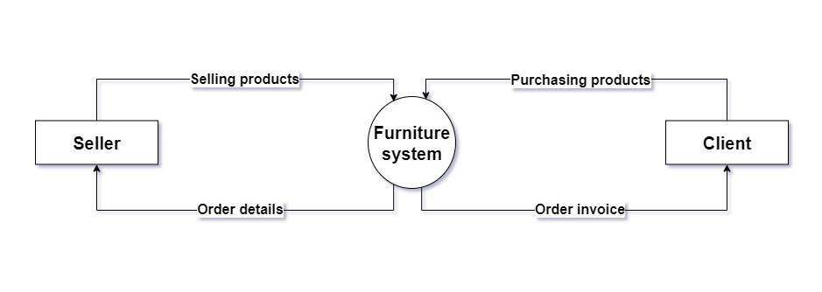

Figure 3.2.1 Context diagram of the whole system.

**3.2.1 Data Flow Diagram:**

The Data Flow Diagram (DFD) for the Furniture Online Store consists of three main parts: the seller, the management, and the clients. The seller enters their information into the system, including their product details, which are then stored in the product database. Clients can search for products on the website and add them to their cart, and place orders. The management team has overall control of the system and is responsible for setting constraints as well as overseeing the shipping process. The DFD shows how data flows between the different parts of the system, and how they interact with each other to ensure smooth operation of the online store. Figure 3.2.2 illustrates the DFD.

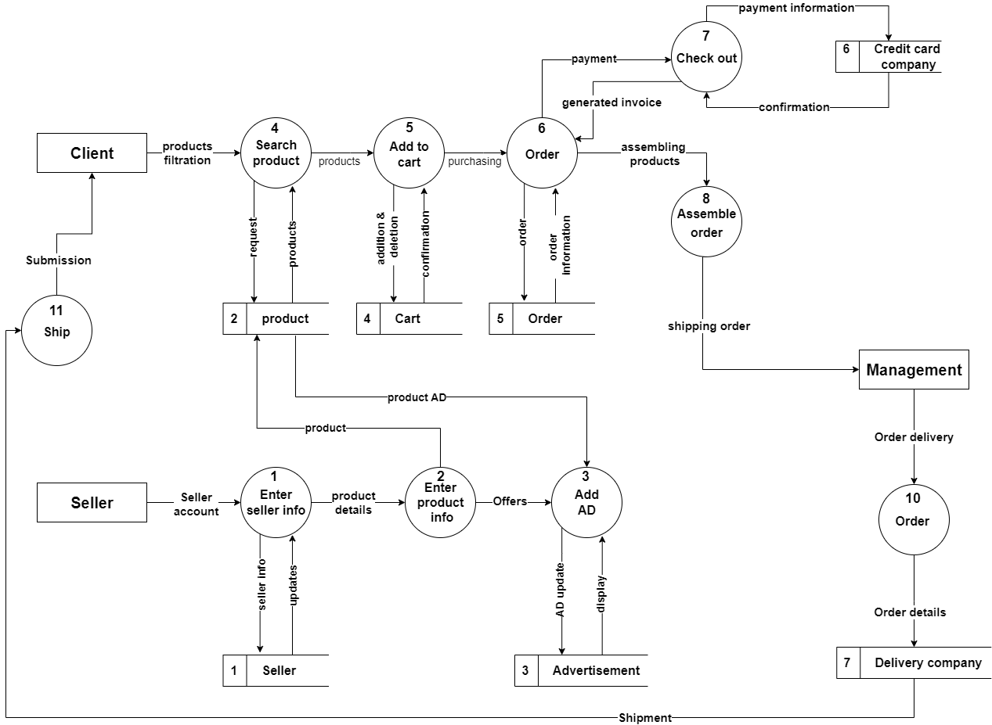

Figure 3.2.2 Data Flow Diagram of the system.

**3.2.2 Use Cases:**

These Use Cases describe the main actions and interactions between the different actors in the system and help to identify the key requirements and functionalities of the online store. They can be used to guide the design and development of the system, ensuring that it meets the needs and expectations of all stakeholders.

Figure 3.2.3 illustrates the Use Case Diagram of the Whole system.

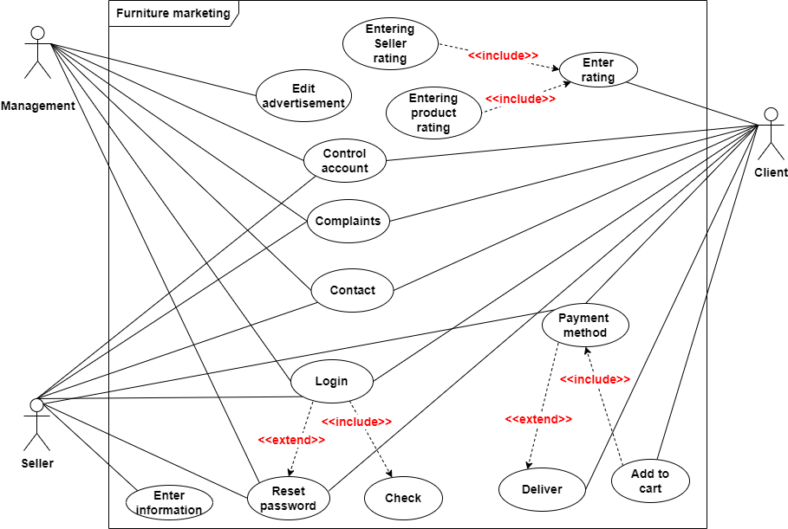

Figure 3.2.3 Use Case Diagram of the system.

The following sequence of tables describes use cases of the important functionalities of the system.

|  |  |  |  |  |  |  |
| --- | --- | --- | --- | --- | --- | --- |
| Use Case Name: Login | | | ID: 1 | | | Priority: High |
| Actor: Manager, Seller, Client | | | | | | |
| Description: This use case describes how a user (Manager, Seller, Client) logs into the System by  using their account information before they can use system. | | | | | | |
| Checkbox Checked with solid fillTrigger: User requests to login.  Type: External Temporal | | | | | | |
| Precondition:  1. The user has not already logged into the system.  2. The user is trying to log in with their account. | | | | | | |
| Normal Course:  1. User accesses the URL  2. The system prompts the user for their account credentials.  3. The user enters their username and password.  4. The system authenticates the login.  5. The user gains access to the systems functionality. | | | | Information for steps:  Email account  Password account  Request confirmation  Control functions | | |
| Alternative:  1. Invalid account user or password.  2. User already logged into the system before. | | | | Reset password | | |
| Postcondition:  1. The user is logged in to the system.  2. The user has access to the functions of the system. | | | | | | |
| Exceptions:  1. Incorrect password or email.  2. Server crash.  3. Power cut off. | | | | | | |
| Summary Inputs Source Outputs Destination | | | | | | |
| * Email * Password | * User (Manager, Seller, Client). | * Request confirmation * Reset password | | | * User (Manager, Seller, Client). | |

Table 3.2.1 Login use case.

|  |  |  |  |  |  |  |
| --- | --- | --- | --- | --- | --- | --- |
| Use Case Name: Resetting Password | | ID: 2 | | | | Priority: High |
| Actor: Manager, Seller, Client | | | | | | |
| Description: This use case helps the user to set a new password. | | | | | | |
| Checkbox Checked with solid fillTrigger: User clicks on “FORGOT PASSWORD?!”.  Type: External Temporal | | | | | | |
| Precondition:  1. The user forgets the password.  2. The user can’t access the system using their password. | | | | | | |
| Normal Course:  1. The user writes the correct username and the incorrect password.  2. The system shows an “invalid username or password” message error.  3. The user clicks on the “FORGOT PASSWORD” link.  4. The system displays the page where the user needs to answer  security questions about their username and phone number(verification).  5. The user answers the questions.  6. The system sends an SMS code to the phone number for verification and prompts the user to re-enter the code.  7. The user enters the code.  8. The system displays whether the code is correct or not, if wrong the  system generates a new code and sends it.  9. If right, the system will update user new password. | | | | Information for steps:    Username and password.  Error message.  Answers.  Code sent to the user.  Users enter code.  Error message.  Update new password. | | |
| Alternative:   1. Admin creates a new password and sends it through the user email If the system is hacked. | | | | Reset password.  Send password. | | |
| Summary  Inputs Source Outputs Destination | | | | | | |
| * Answers question * phone number * Verification code * New password | * User (Students and   Staff info)   * System code   generator | | * Verification * confirmation | | * User (Manager, Seller, Client) | |

Table 3.2.2 Resetting Password use case.

|  |  |  |  |  |  |  |
| --- | --- | --- | --- | --- | --- | --- |
| Use Case Name: Enter information | | | ID: 10 | | Priority: High | |
| Actor: Seller | | | | | | |
| Description: This use case describes how the seller enter his information, then enter product information. | | | | | | |
| Checkbox Checked with solid fillTrigger: Seller enters his information and product information.  Type: External Temporal | | | | | | |
| Precondition:   1. The System must authenticate that the seller enters all his information before entering product information. | | | | | | |
| Normal Course:   1. The seller enters his information. 2. The seller enters product information. 3. The seller updates the product information. | | | | Information for steps:  Seller database.  Inventory database.  Inventory database. | | |
| Alternative:   1. The seller not complete entering information, then return to   complete it | | | | Seller database.  Inventory database. | | |
| Postcondition:   1. The system will send notification or email to the seller if the product has been sold. 2. The seller should be checking continuously the website for contacts or sold products. | | | | | | |
| Exceptions:  1. product issues.  2. Server crash.  3. Power cut off. | | | | | | |
| Summary Inputs Source Outputs Destination | | | | | | |
| * Seller information * Product information | * Seller | * Product with a description. | | | | * clients |

Table 3.2.3 Enter information use case.

|  |  |  |  |  |  |  |
| --- | --- | --- | --- | --- | --- | --- |
| Use Case Name: Complaints | | | ID: 5 | | Priority: Low | |
| Actor: Manager, Seller, Client | | | | | | |
| Description: This use case describes how a user (Seller, Client) Sending Complaints through mailbox for the management. | | | | | | |
| Checkbox Checked with solid fillTrigger: problems face the user (Seller, Client).  Type: External Temporal | | | | | | |
| Precondition:   1. Problems face users. 2. Users can’t solve these problems. 3. The product is not in good condition when it delivered to client. | | | | | | |
| Normal Course:  1. The user click on “Complaints.”  2. The user writes his complaint, then sends it to the management.  3. The management received the complaint message. | | | | Information for steps:  Complaint table.  Complaint content.  Complaint content. | | |
| Alternative:  1. Invalid account user or password.  2. User already logged into the system before. | | | | Reset password | | |
| Postcondition:   1. Solving problems of users. 2. If it is a fraud case, the owner's account will be deleted, and the police will be reported with this fraud. | | | | | | |
| Exceptions:  1. Incorrect password or email.  2. Server crash.  3. Power cut off.  4. Fraud process. | | | | | | |
| Summary Inputs Source Outputs Destination | | | | | | |
| * Complaint message. | * User (Seller, Client). | * Solving problem. | | | | * Management. |

Table 3.2.4 Complaints use case.

|  |  |  |  |  |  |  |
| --- | --- | --- | --- | --- | --- | --- |
| Use Case Name: Control account | | | ID: 3 | | Priority: Low | |
| Actor: Manager, Seller, Client | | | | | | |
| * Description: This use case describes how a user (Manager, Seller, Client) update his account information   (ex. Address, phone, name). | | | | | | |
| Checkbox Checked with solid fillTrigger: Update user information.  Type: External Temporal | | | | | | |
| Precondition:  1. The user logged into the system. | | | | | | |
| Normal Course:  1. The user authenticates the login.  2. The user click on Control account update his information.  3. The user update account information (ex. address).  4. The user click on image position to upload his picture. | | | | Information for steps:  Verification.  Show information.  Update database.  Update database. | | |
| Alternative:  1. User send complaints about problems with his information. | | | | Send complaints. | | |
| Postcondition:  1. The user save his changes.  2. The user receive confirmation message. | | | | | | |
| Exceptions:   1. Failed to update information. 2. Failed to upload his picture.   3. Server crash.  4. Power cut off. | | | | | | |
| Summary Inputs Source Outputs Destination | | | | | | |
| * User information * User picture | * User (Manager, Seller, Client) | * Updated information * Confirmation message | | | | * User (Manager, Seller, Client) |

Table 3.2.5 Control account use case.

|  |  |  |  |  |  |  |
| --- | --- | --- | --- | --- | --- | --- |
| Use Case Name: Add to cart | | | ID: 7 | Priority: High | | |
| Actor: Client | | | | | | |
| Description: This use case describes how a client adds all products he wanted to purchase in a cart to collect them to buy them for one time. | | | | | | |
| Checkbox Checked with solid fillTrigger: The client collects products he wanted to purchase in a cart  Type: External Temporal | | | | | | |
| Precondition:   1. The client search product he wanted. | | | | | | |
| Normal Course:   1. The client adds products he wants to cart. 2. The client adds all the other products he needs. 3. Click Remove to remove selected orders from card. | | | | | Information for steps:  Update cart  Update cart  Update cart | |
| Alternative:   1. If the client wants to buy one product directly, he should Click “Buy”.   Which will make order directly. | | | | | Orders | |
| Postcondition:   1. When the client wants to buy all, he adds to cart, he should go to cart and but product. | | | | | | |
| Exceptions:  1. Server crash.  2. Power cut off.  3. Technical problem | | | | | | |
| Summary Inputs Source Outputs Destination | | | | | | |
| * Add products to cart | * Client | * Products added to cart. | | | | * Orders |

Table 3.2.6 Add to cart use case.

|  |  |  |  |  |  |
| --- | --- | --- | --- | --- | --- |
| Use Case Name: All payment method (Orders, Payments, Delivery) | | | ID: 8 | Priority: High | |
| Actor: Client | | | | | |
| Description: This use case describes how the client buy a product. | | | | | |
| Checkbox Checked with solid fillTrigger: Client buys a product.  Type: External Temporal | | | | | |
| Precondition:  1. the client will add Products to cart before buying it. | | | | | |
| Normal Course:   1. The client adds the number of orders of product to cart to collect orders, then buy to purchase product. 2. Client clicks Buy to check out product. 3. System calculates the total price. 4. Send order to payment to pay order. 5. The payment department will complete the payments through credit account numbers. 6. If the payment is completed the order will be send to delivery 7. Delivery will take off the ordered products from inventory. 8. Driver man will deliver the order to the client. | | | Information for steps:  Update Orders  Update Payments  Orders  Payment  Payment  Delivery  Inventory  Delivery | | |
| Alternative:   1. The system will delete orders if the money of the client is not enough to buy. 2. If it happens a cancellation message will appear to client. | | | Update Orders.  Cancellation message. | | |
| Postcondition:   1. The client will receive order details with a confirmation message when payment is completed. 2. The Seller will receive order details with confirmation message when payment is completed. 3. The client will receive Cancellation message if payment is failed. 4. The client will receive the order in the delivery dated time. | | | | | |
| Exceptions:  1. money is not enough.  2. Server crash.  3. Power cut off.  4. Technical issues.  5. delivery issues. | | | | | |
| Summary Inputs Source Outputs Destination | | | | | |
| * order | * Client | * Order details * Delivery of order | | | * Client |

Table 3.2.7 All payment method (Orders, Payments, Delivery) use case.

|  |  |  |  |  |  |  |
| --- | --- | --- | --- | --- | --- | --- |
| Use Case Name: Enter rating of product | | | ID: 9 | | Priority: Medium | |
| Actor: Client | | | | | | |
| Description: This use case describes how the client enter rating of seller and product. | | | | | | |
| Checkbox Checked with solid fillTrigger: Enter seller and product rating.  Type: External Temporal | | | | | | |
| Precondition:   1. The client buys the product. 2. The delivery has arrived. | | | | | | |
| Normal Course:   1. Click number of stars of product rating. 2. Add review comment about product. | | | | Information for steps:  update product table  update product table | | |
| Alternative:   1. The client doesn’t want to enter the rating. 2. He will finish the payment and close the site. | | | |  | | |
| Postcondition:   1. The Client finish payment and receive order details. 2. He may contact the seller. 3. He closes the system. | | | | | | |
| Exceptions:  1. Server crash.  2. Power cut off. | | | | | | |
| Summary Inputs Source Outputs Destination | | | | | | |
| * Product rating * Comment on product. | * Client | * Product stars * Comment on product. | | | | * Product in Inventory |

Table 3.2.8 Enter rating of product use case.

**3.2.3 Entity-relationship diagram (ERD):**

The ERD for the furniture online store consists of three main entities: seller, management, and clients. The ERD includes relationships between these entities, such as the relationship between the client entity and the order entity, indicating that clients can place orders. The ERD also includes attributes for each entity, such as the product name, price, and quantity for the product entity. ERD helps designers and developers to understand the data structure of a database, identify potential problems, and optimize the database design.

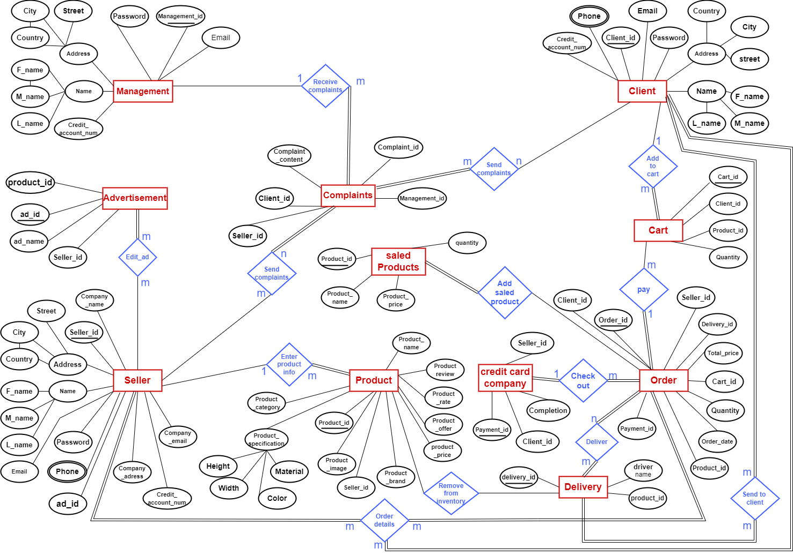

Figure 3.2.4 Entity-relationship diagram of the system.

**3.2.4 Structure Charts:**

Structure Chart illustrates the hierarchy and relationships between program modules or functions in a software system. It is used to represent the organization of modules in a structured programming or software engineering environment. The modules are represented as rectangles or boxes, with arrows indicating the data flow and control flow between them. It helps in visualizing the structure of a software system, identifying reusable modules, and optimizing the design of the system. The following sequence of charts illustrates structure charts of the important functionalities of the system.

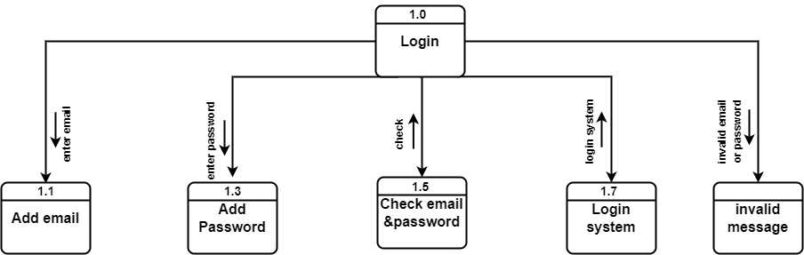

Figure 3.2.5 Login structure chart.

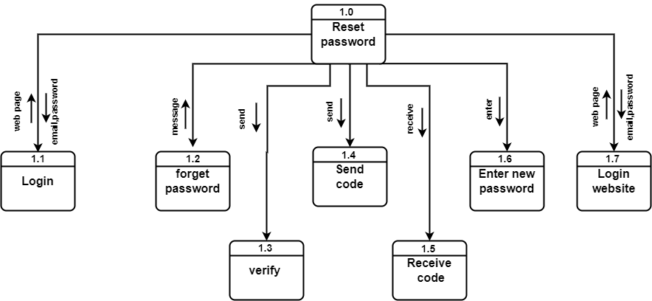

Figure 3.2.6 Reset password structure chart.

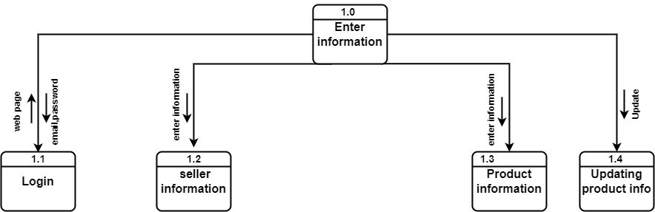

Figure 3.2.7 Enter information structure chart.

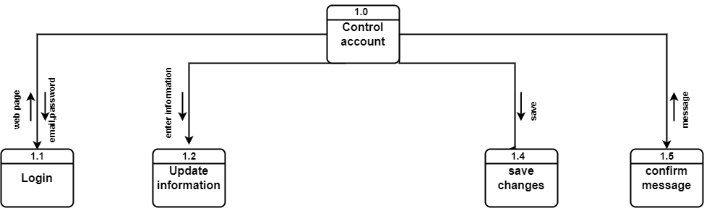

Figure 3.2.8 Control account structure chart.

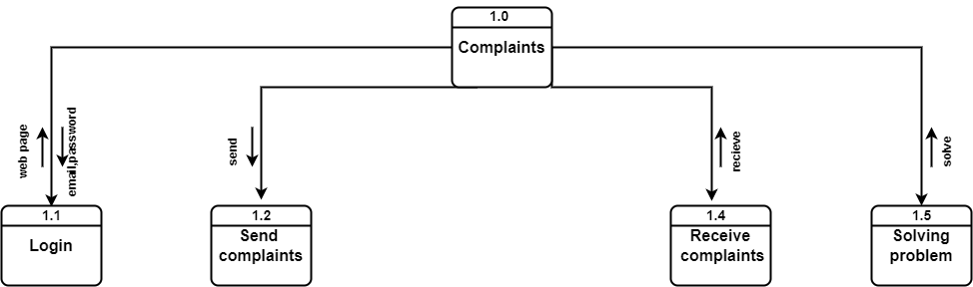

Figure 3.2.9 Complaints structure chart.

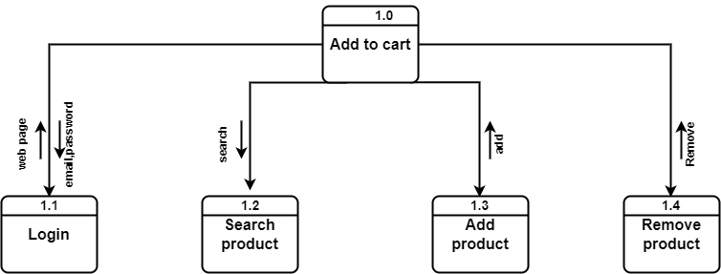

Figure 3.2.10 Add to cart structure chart.

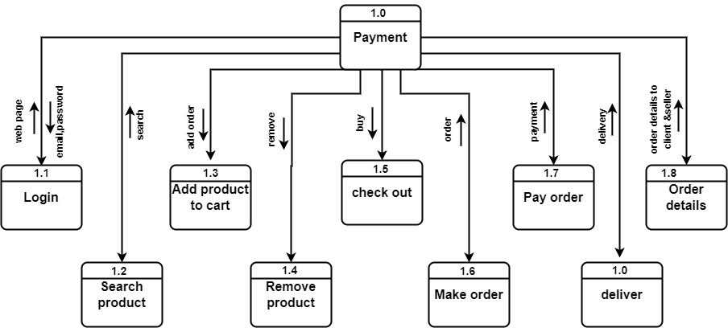

Figure 3.2.11 Payment structure chart.

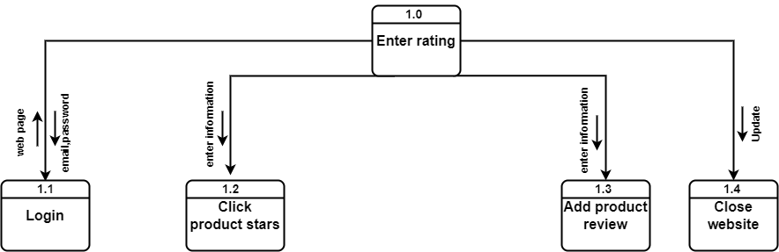

Figure 3.2.12 Enter rating structure chart.

* 1. **System tools and technologies:**

Our project encompasses both a website and mobile application, and to create an effective and engaging user experience, we have utilized a range of tools and technologies across frontend, backend, and mobile app development.

* + 1. **System analysis:**

We have performed a thorough system analysis using diagrams.net to identify and address potential issues and optimize the performance of our website and mobile app and to create system architecture diagrams and visualize the components and interactions of our system.

* + 1. **User Interface and User Experience (UI/UX):**

To design the user interface and user experience, we have used Adobe XD, Adobe Photoshop, and Adobe Illustrator. These tools have allowed us to create wireframes, mockups, and prototypes for testing and refining the design before implementation.

* + 1. **Frontend Development:**

For frontend development, we have used HTML, CSS, and JavaScript to create the visual and interactive elements of our website. Additionally, we have leveraged the Bootstrap framework and Swiper.js library to enhance the styling and functionality of our interfaces. The React.js library has also been used to build complex user interfaces.

* + 1. **Mobile App Development:**

To develop our mobile app, we have utilized Flutter, an open-source mobile application development framework created by Google. Flutter allows us to build native-looking interfaces for both iOS and Android platforms. We have also used the Material and Cupertino design systems to create a consistent and seamless experience across the two platforms.

* + 1. **Backend Development:**

For server-side scripting, we have used PHP and the Laravel framework to manage data and perform server-side processing. MySQL has been used for database management.

**CHAPTER 4**

**System Design**

1. **System Design:**

The system design for the furniture online store consists of three main parts: the seller interface, the client interface, and the management interface. The seller interface is designed to allow sellers to enter their personal information, add product details, and manage their inventory. The client interface is designed to allow clients to search for products, add them to their cart, and place orders. The management interface is designed to allow the system administrators to manage the entire system, set constraints, and handle the shipping process. The system design also includes a database that stores information about sellers, clients, products, orders, and other important data. The database is designed to be scalable and efficient, allowing for easy management and retrieval of information. The system design also includes the interface design refers to the process of designing the user interface of a software application or system. It involves creating the visual and interactive elements of the user interface. The overall system design is user-friendly, intuitive, and efficient, providing a seamless experience for sellers, clients, and system administrators.

* 1. **Physical ERD:**

A Physical ERD is a diagram that shows how a database is structured at a physical level, including tables, columns, and data types. It is used to implement and build a database and to ensure that it meets the users' requirements. It can also include indexes, keys, and other database objects to optimize the performance of the database.

Figure 4.1.1 illustrates the physical ERD of the Whole system.

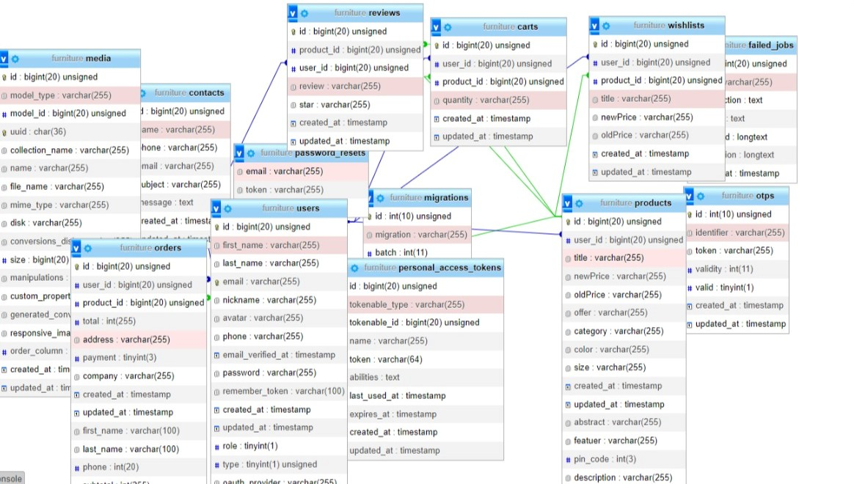

Figure 4.1.1 Physical ERD.

* 1. **System LOGO:**

Figure 4.2.1 System LOGO.

* 1. **UIUX:**

The UI/UX (User Interface/User Experience) of a mobile app refers to how the app looks and feels, as well as how easy it is to use and navigate. It includes the design of the visual elements of the app, such as the layout, typography, color scheme, and images, as well as the interaction design, such as the navigation, gestures, and feedback. A good UI/UX design aims to provide a seamless and enjoyable experience for the user, by anticipating their needs, simplifying tasks, and providing clear and helpful guidance. It should be intuitive, responsive, and accessible, and take into consideration the limitations and capabilities of mobile devices.

The following sequence of Figures illustrates the UIUX design of the mobile application.

Figures 4.3.1 UIUX of the mobile application.

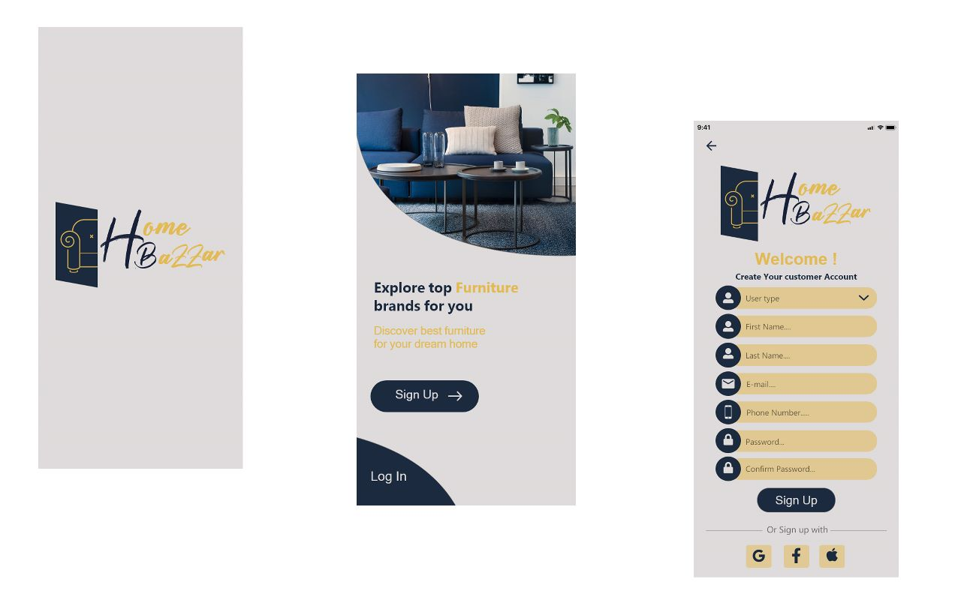

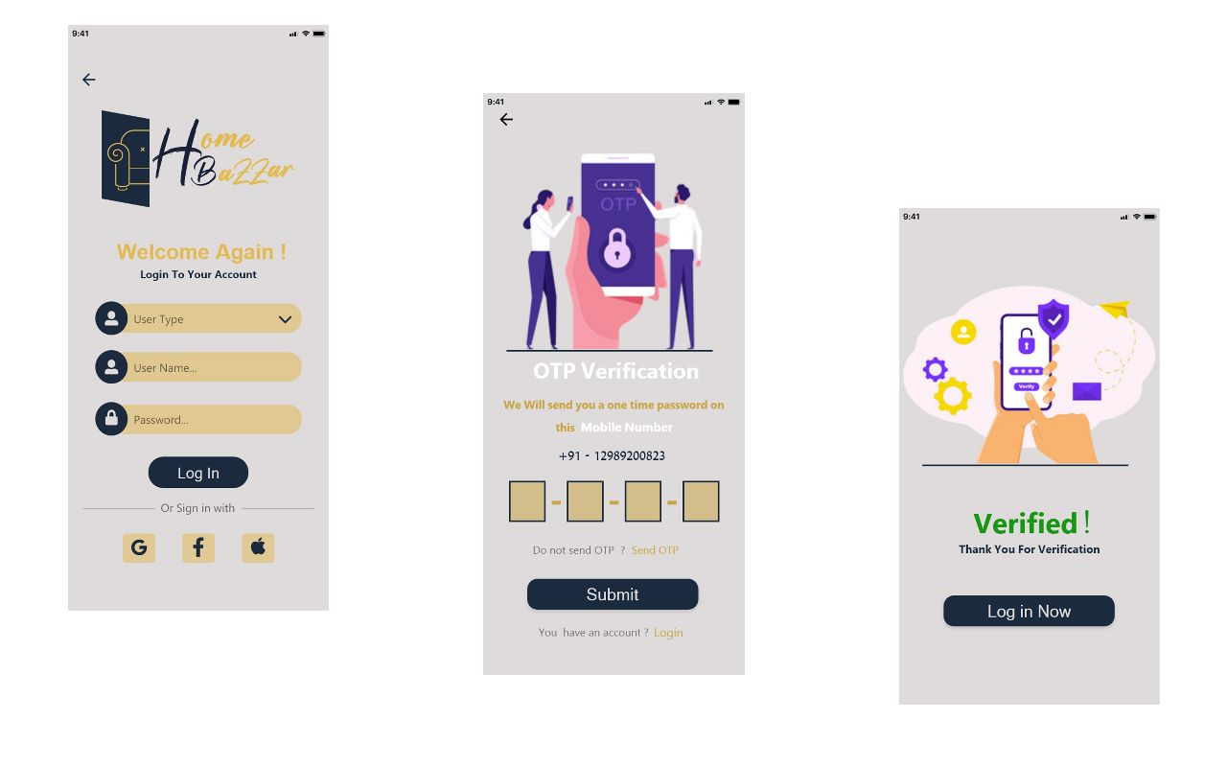

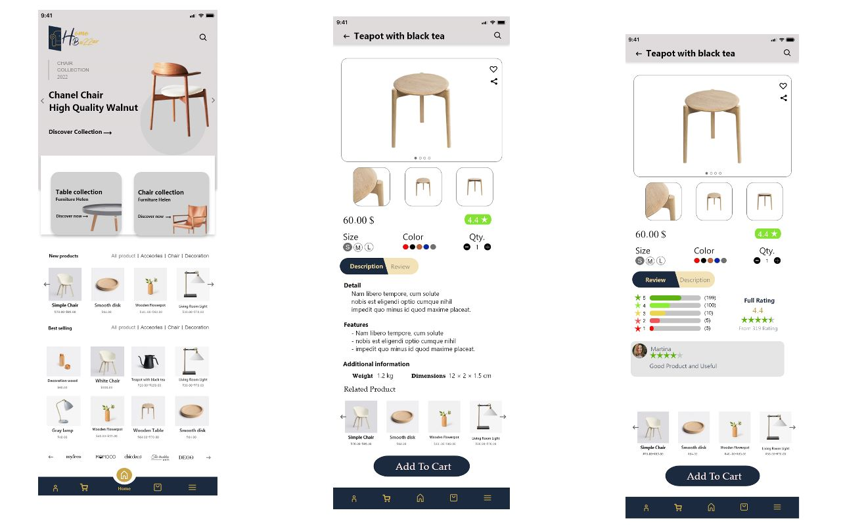

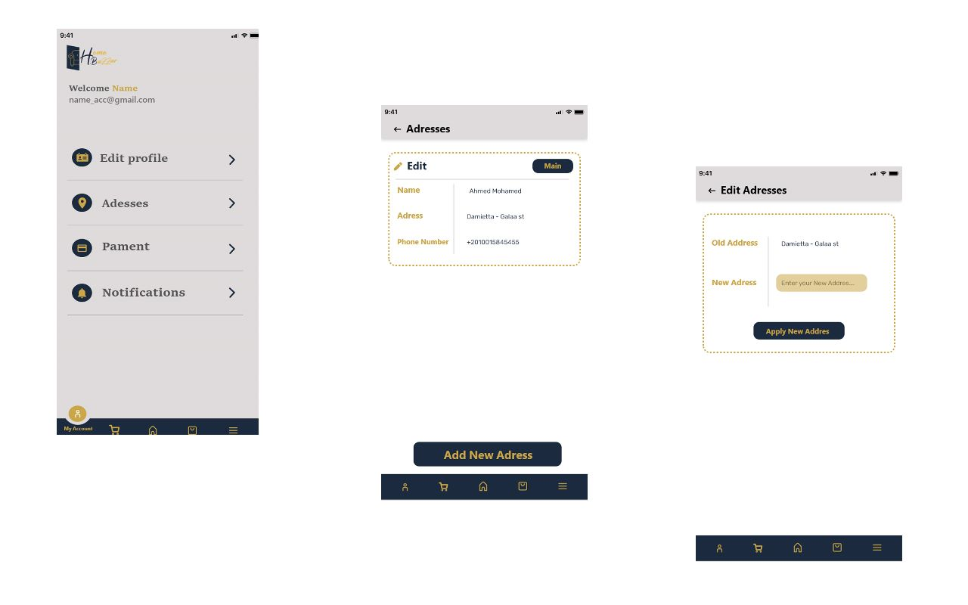

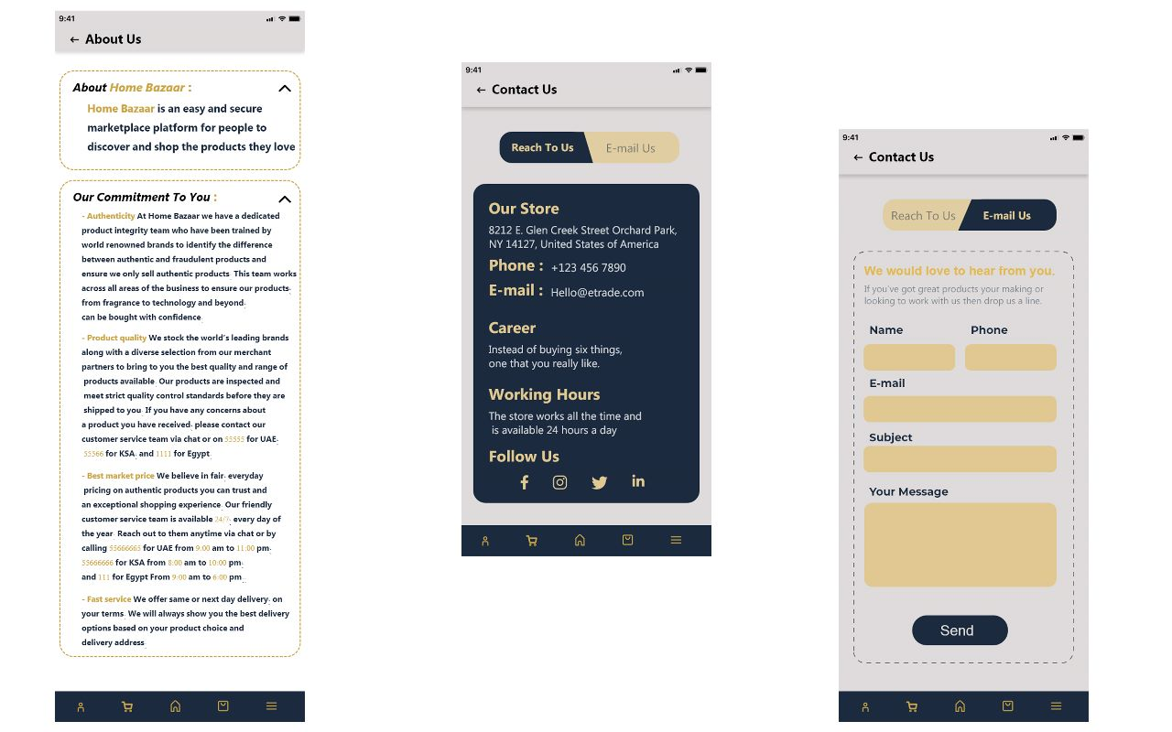

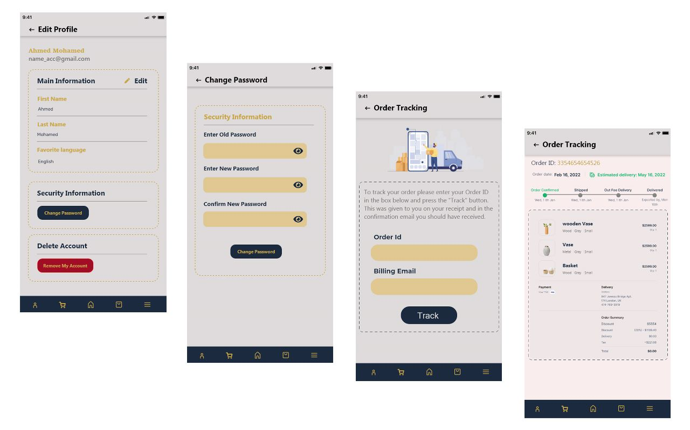

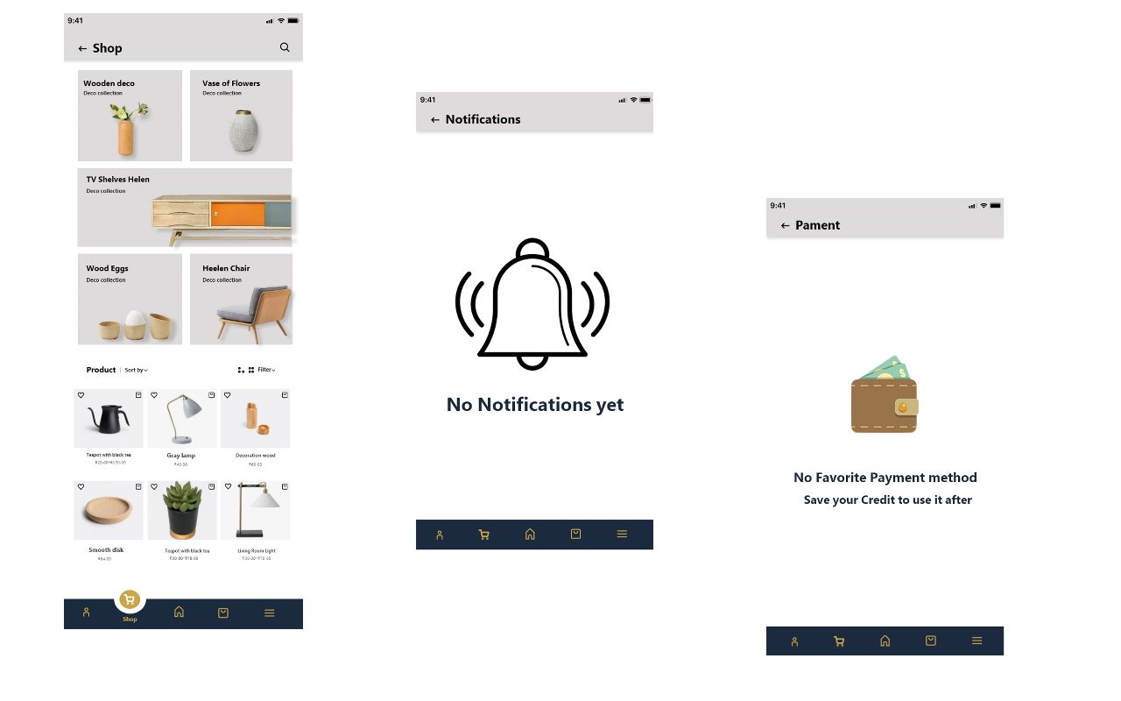

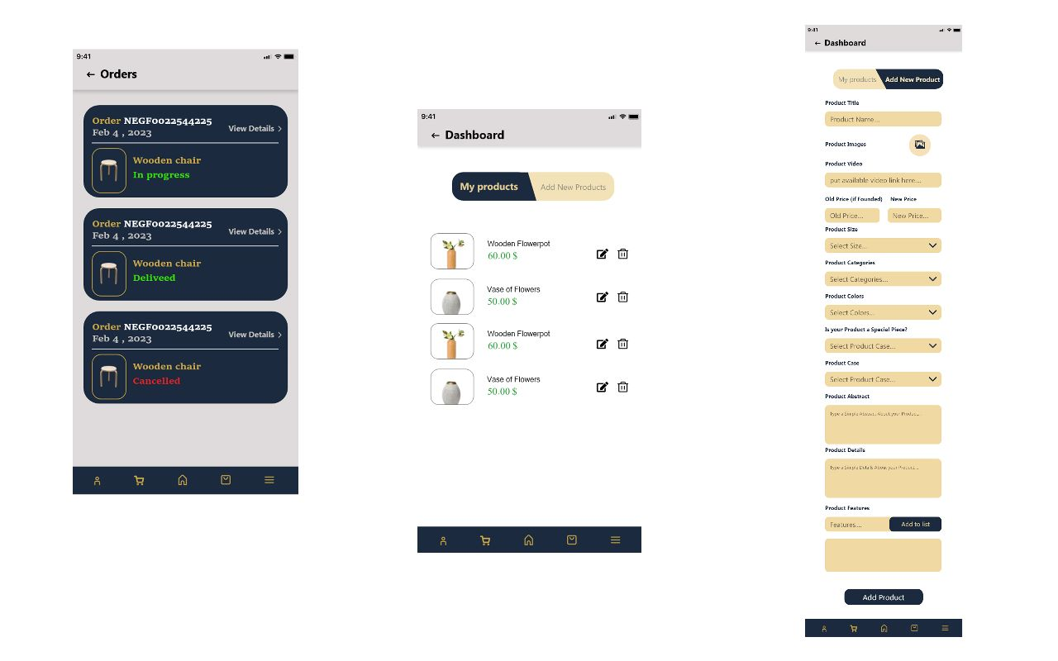

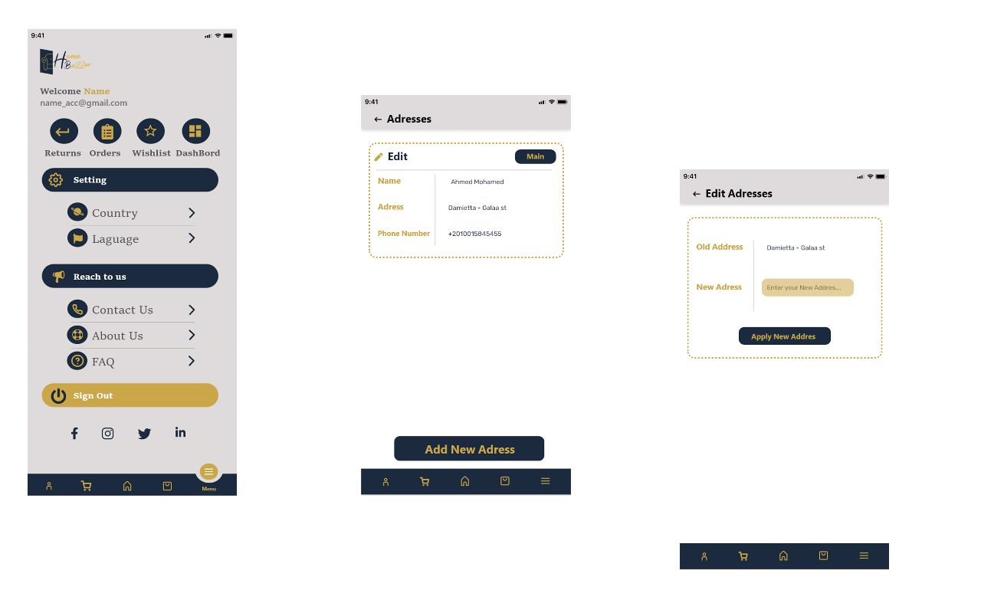

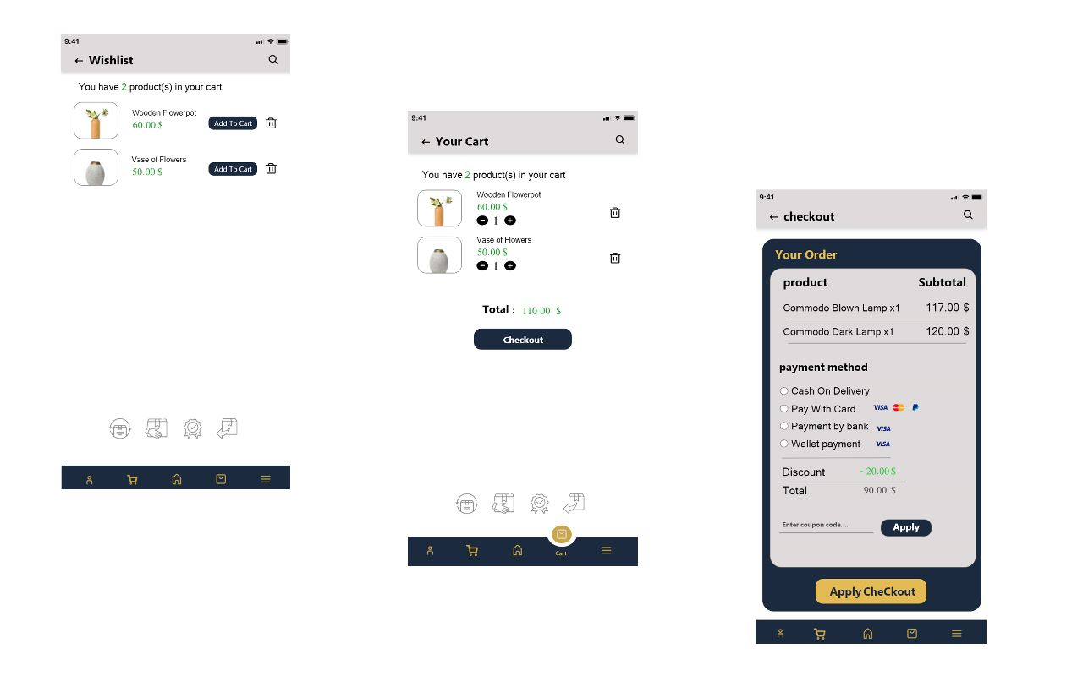

**CHAPTER 5**

**System Implementation**

1. **System Implementation:**

In system implementation we turned the system design into a functional system. For our Furniture Online Store project, this involves developing both the website and mobile application. The implementation phase includes coding, testing, debugging, and integrating the various components of the system. The interface design of the website and application is also an essential part of the implementation phase, ensuring that the visual and interactive elements of the user interface are designed to be user-friendly, intuitive, and aesthetically pleasing.

* 1. **Interface Design of the website:**

The following sequence of Figures illustrates the interface design.

Figures 4.4.1 Interface Design of the website.

Home page:

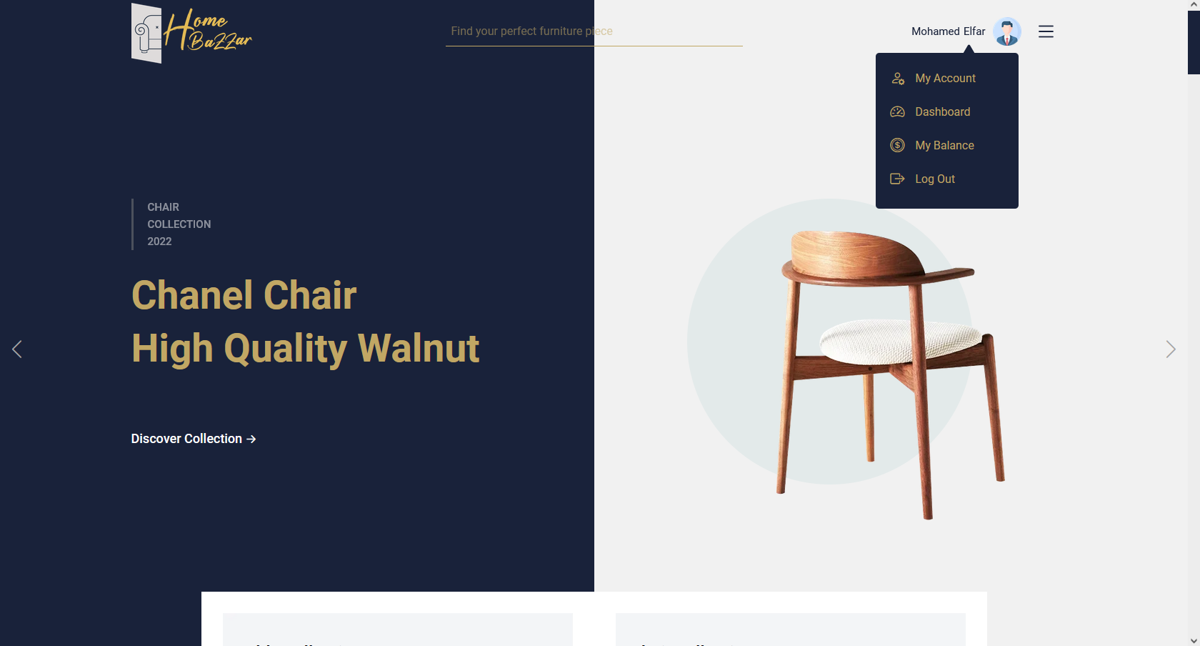

Offers:

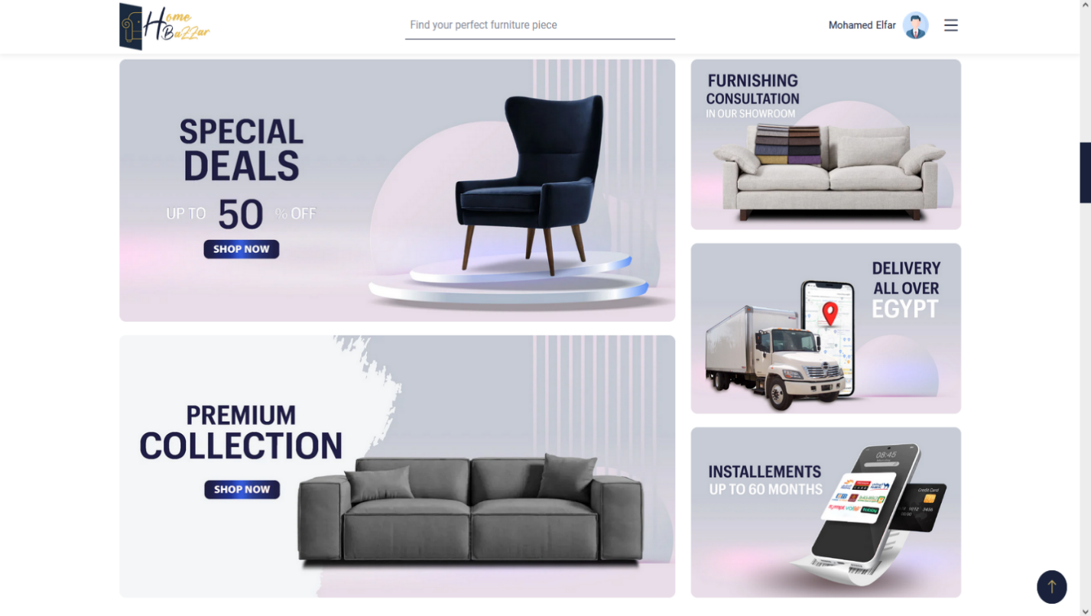

Top Rating:

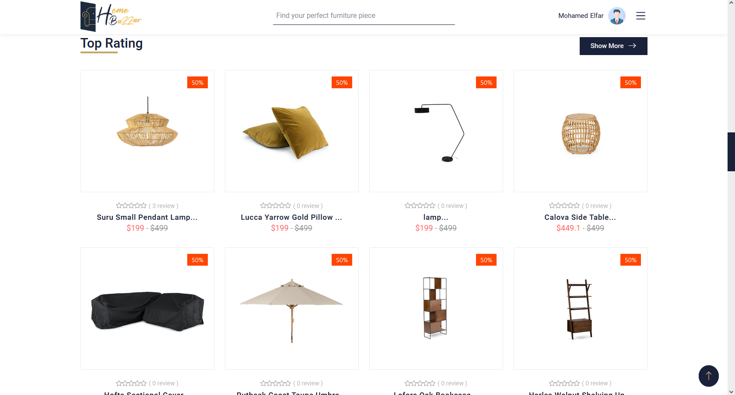

Unfinished Products:

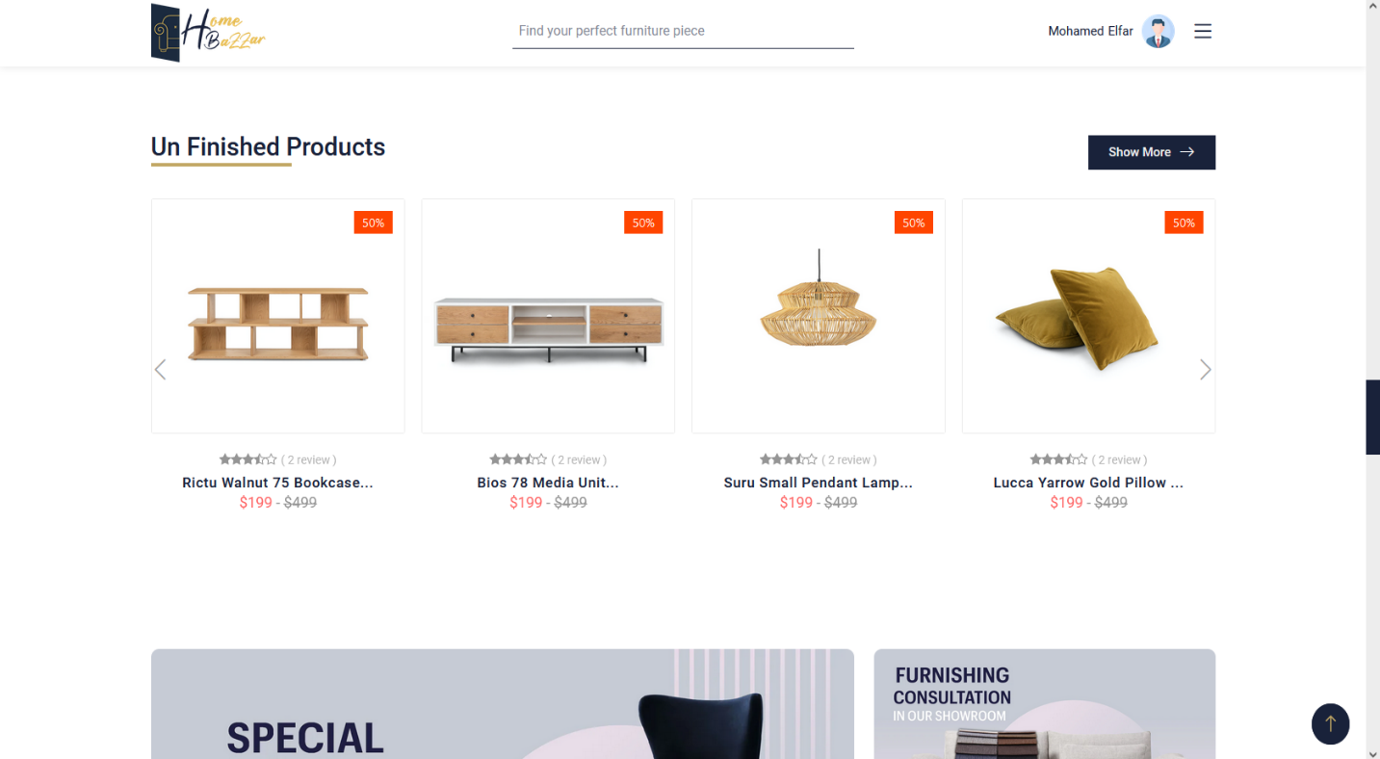

About Us:

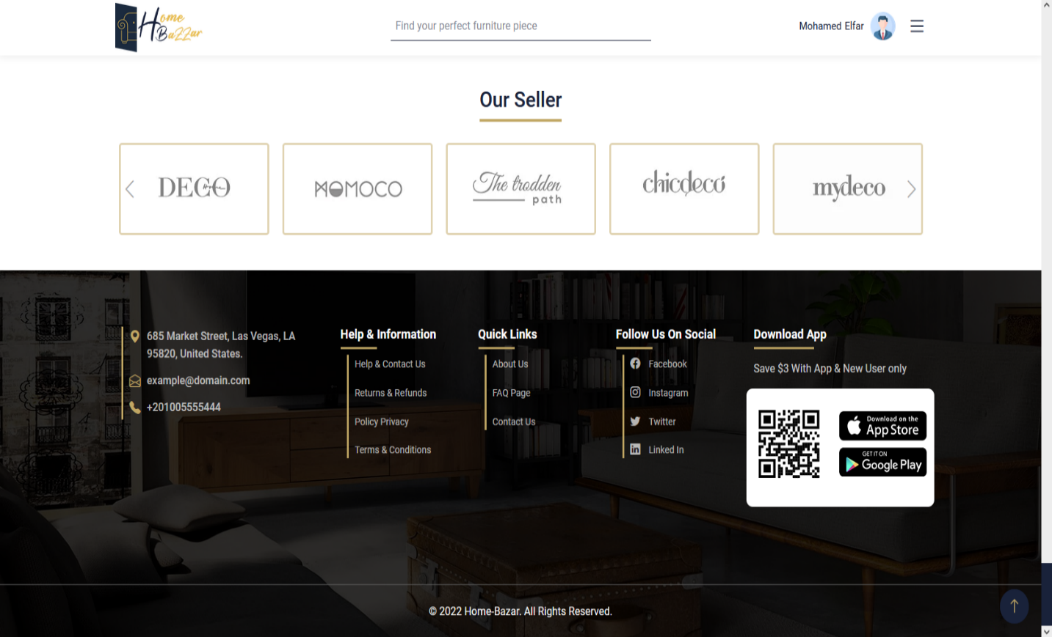

Shop:

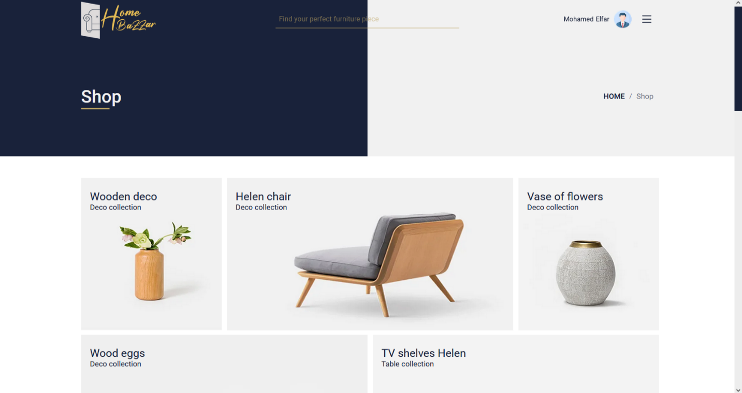

Filter:

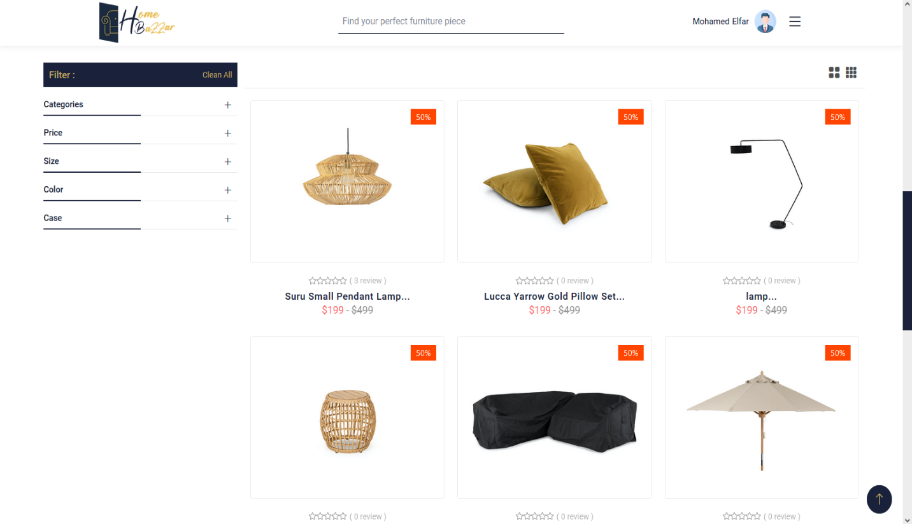

My Account:

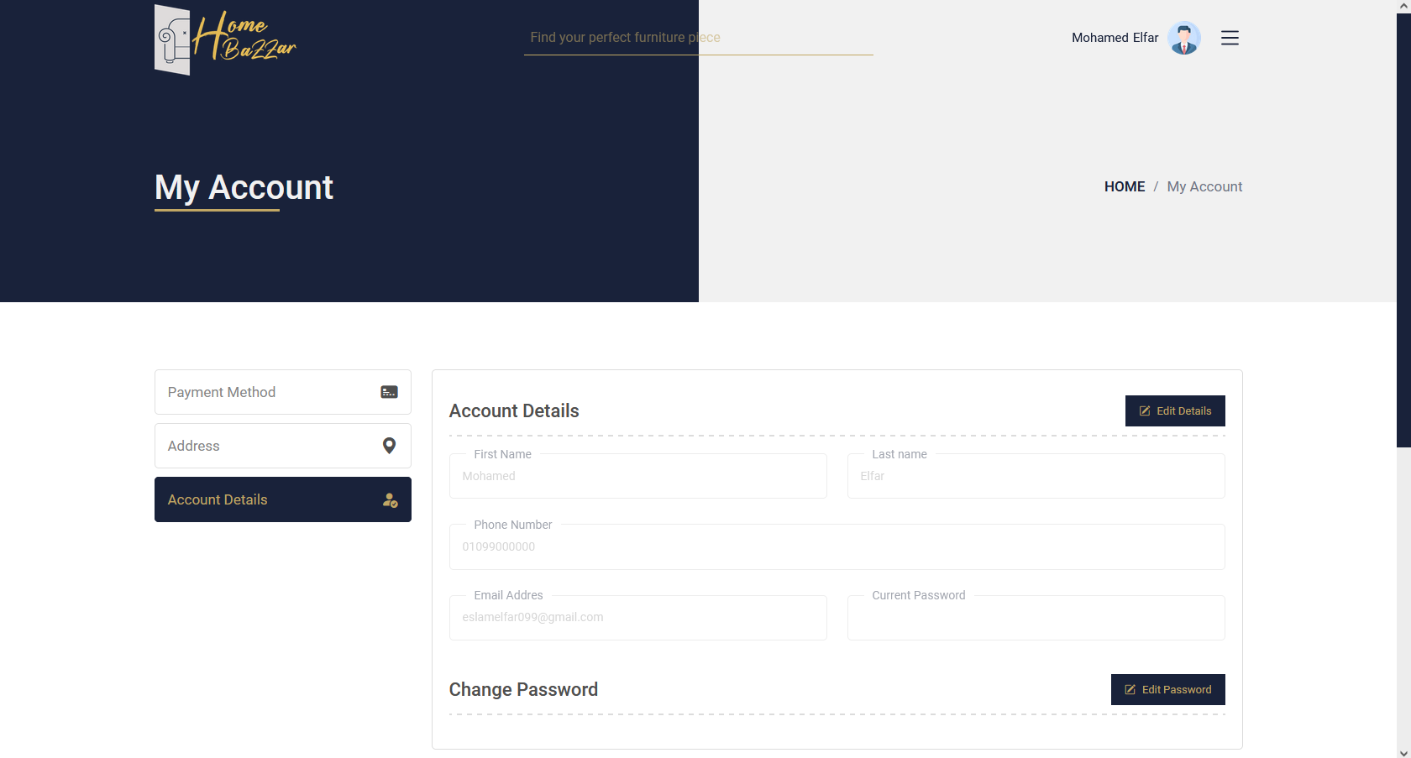

Dashboard:

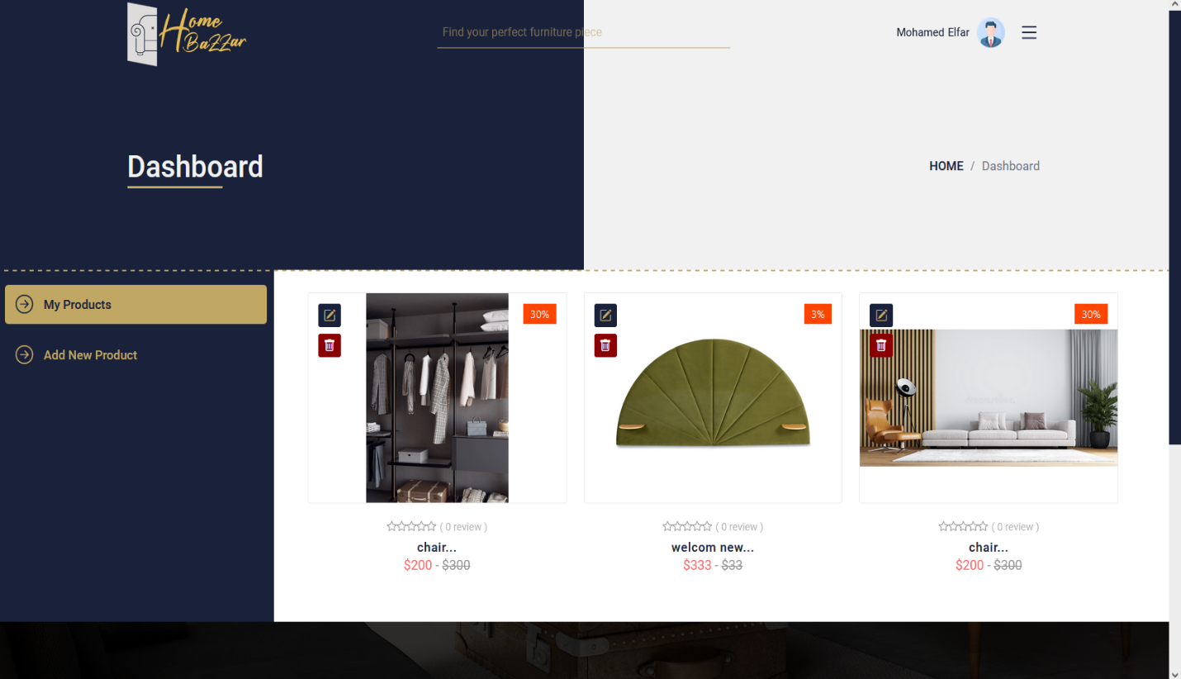

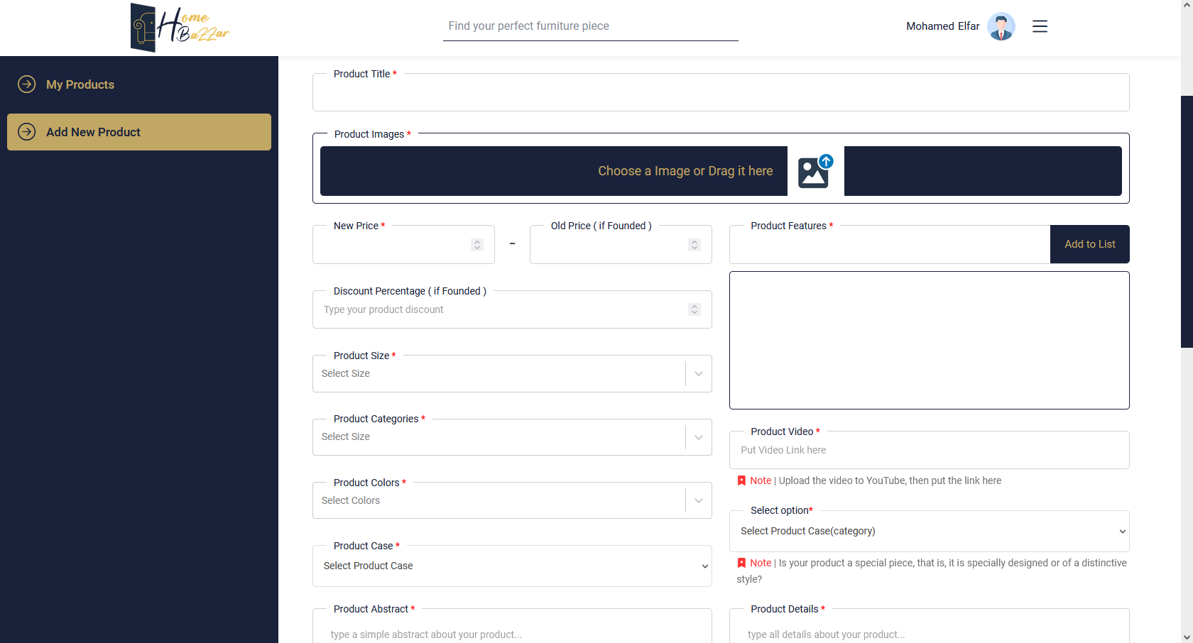

My Balance:

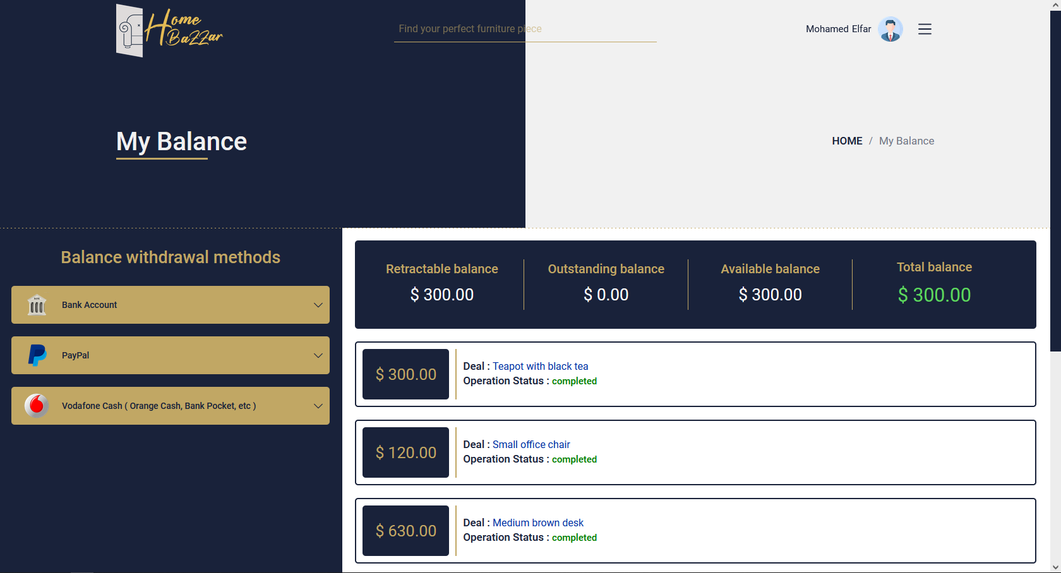

Contact Us:

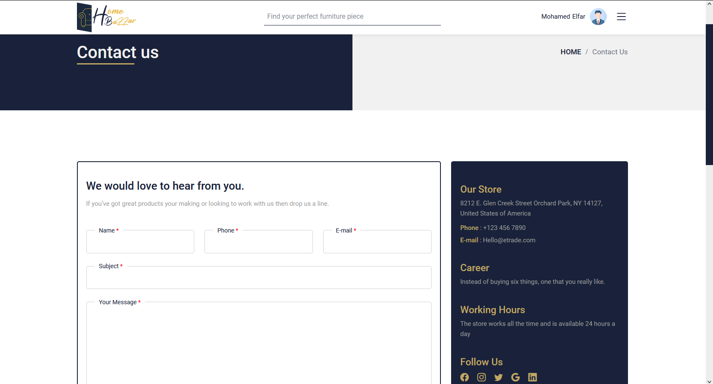

Ordering / Add To Cart:

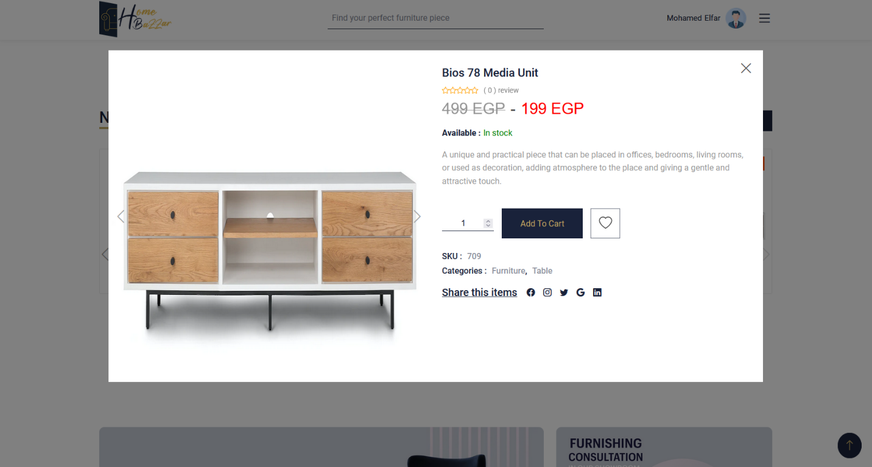

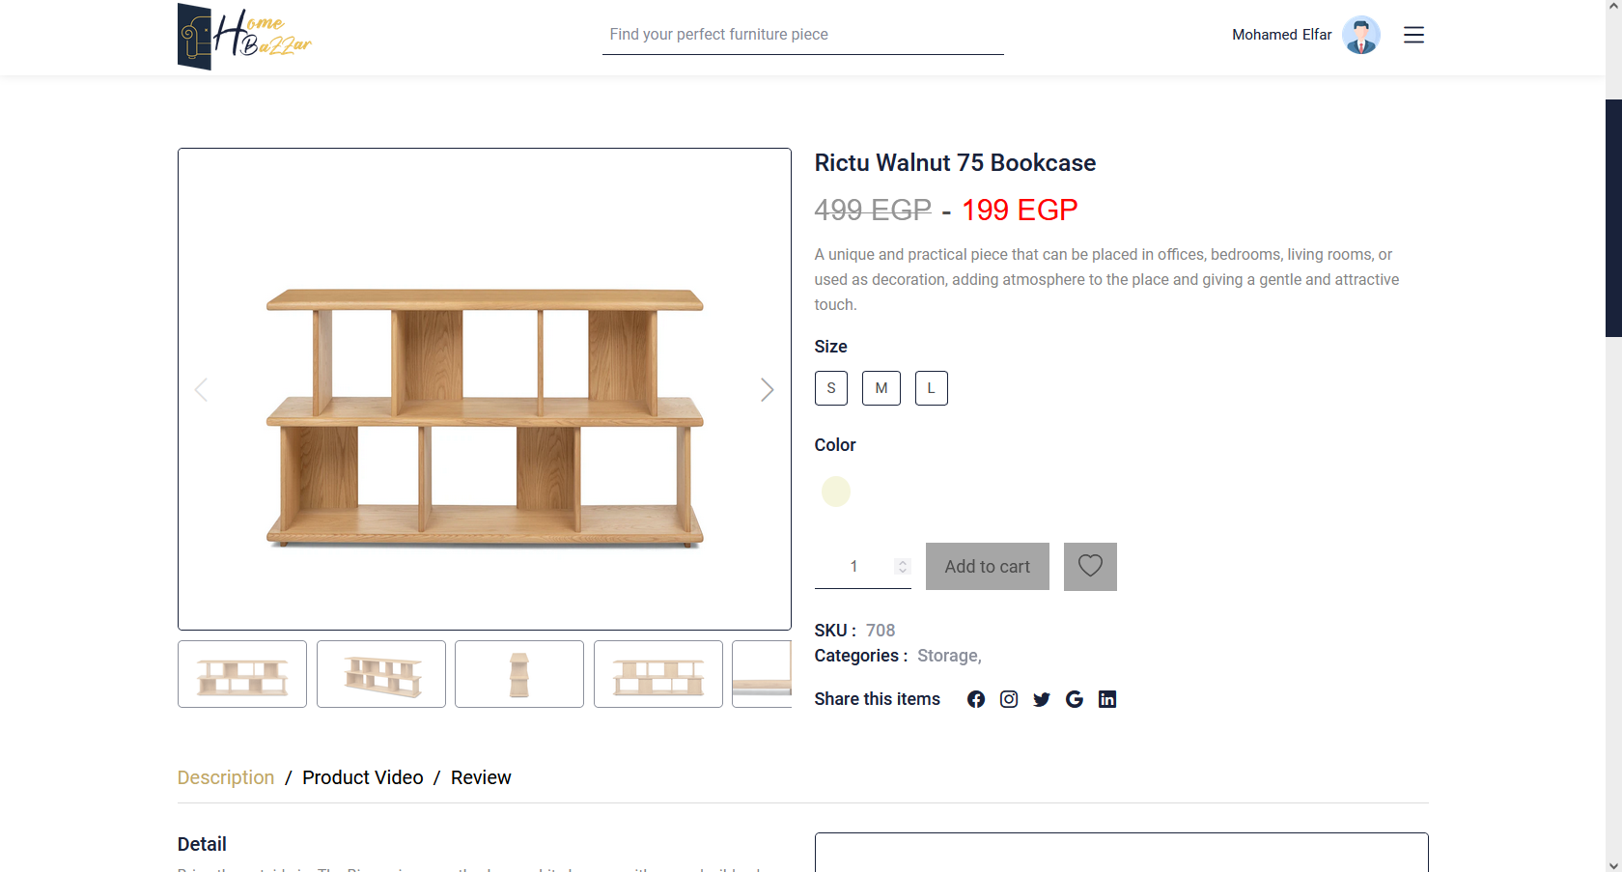

Exploring product:

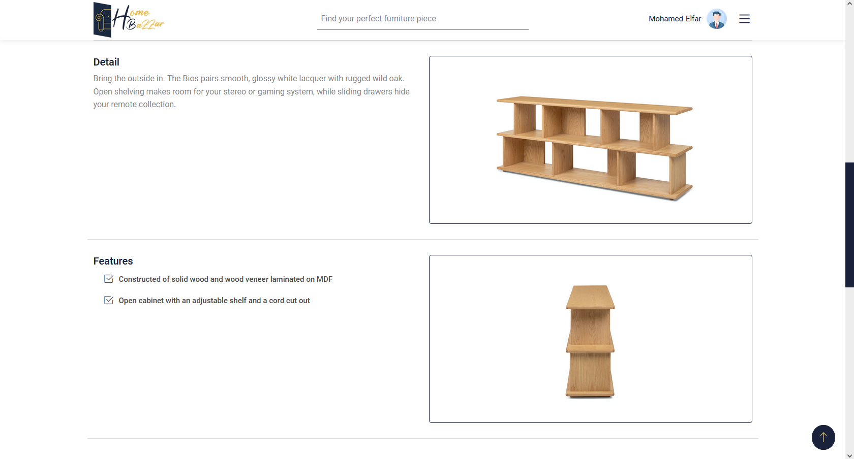

Checkout:

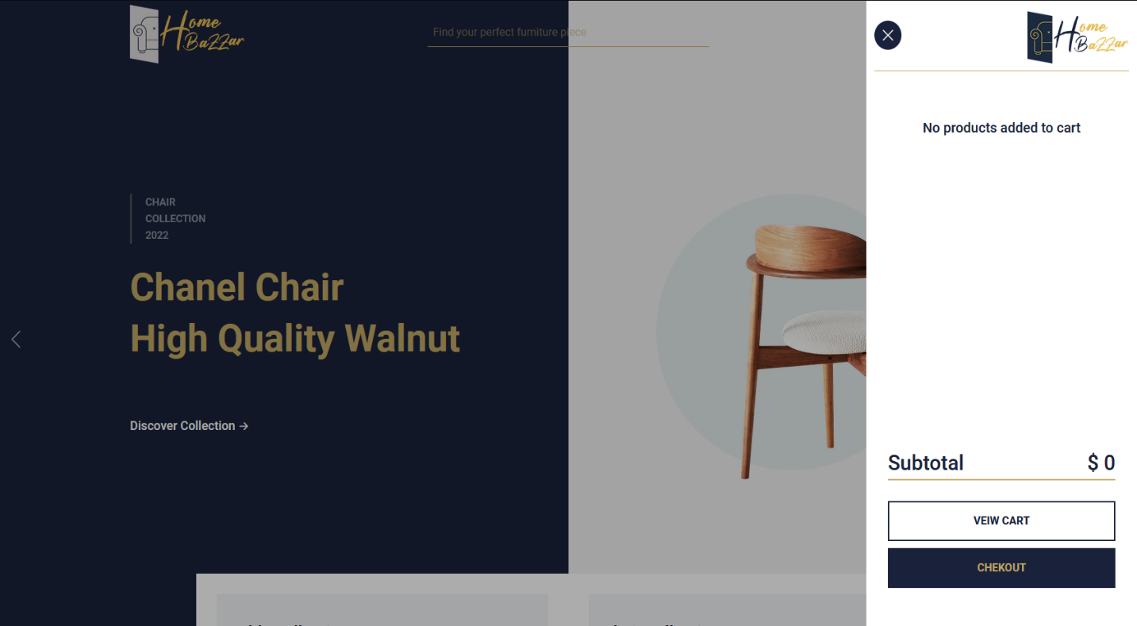

Wishlist:

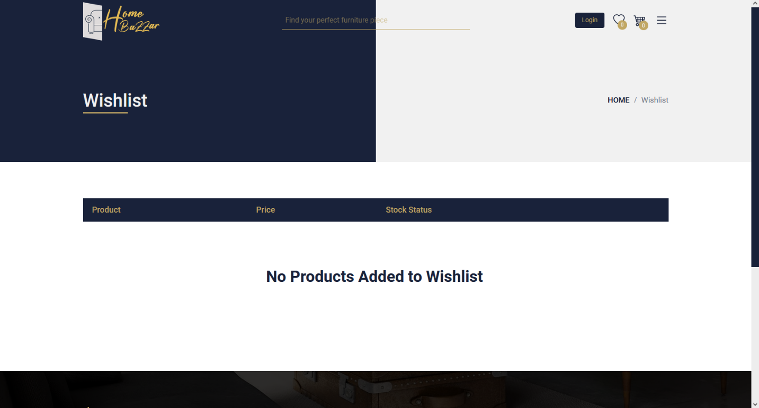

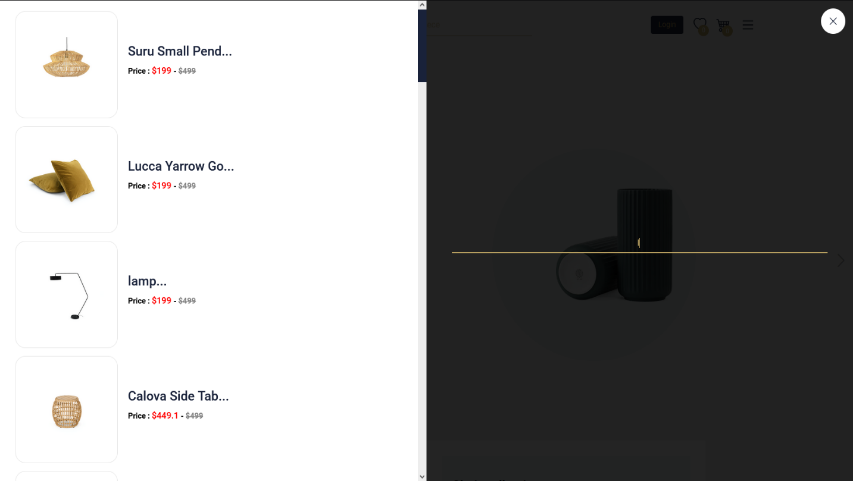

Create Account:

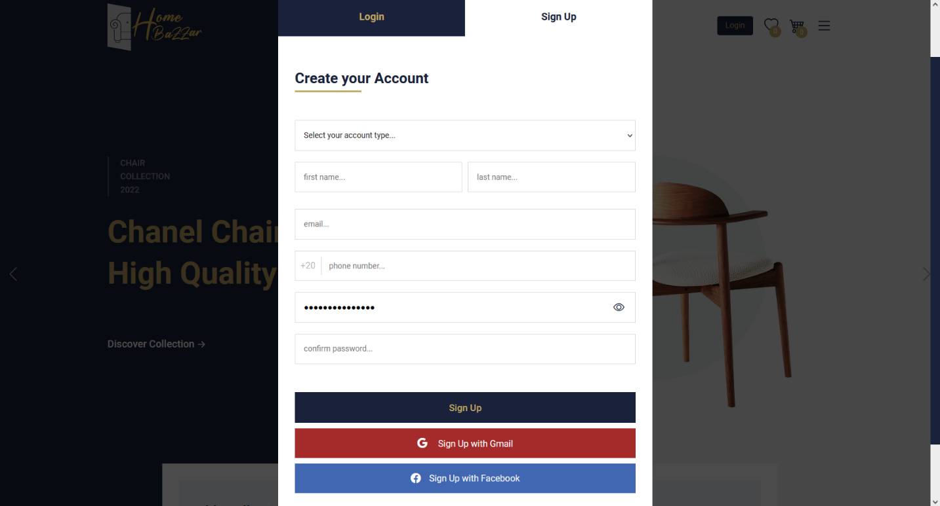

Sign Up / Login:

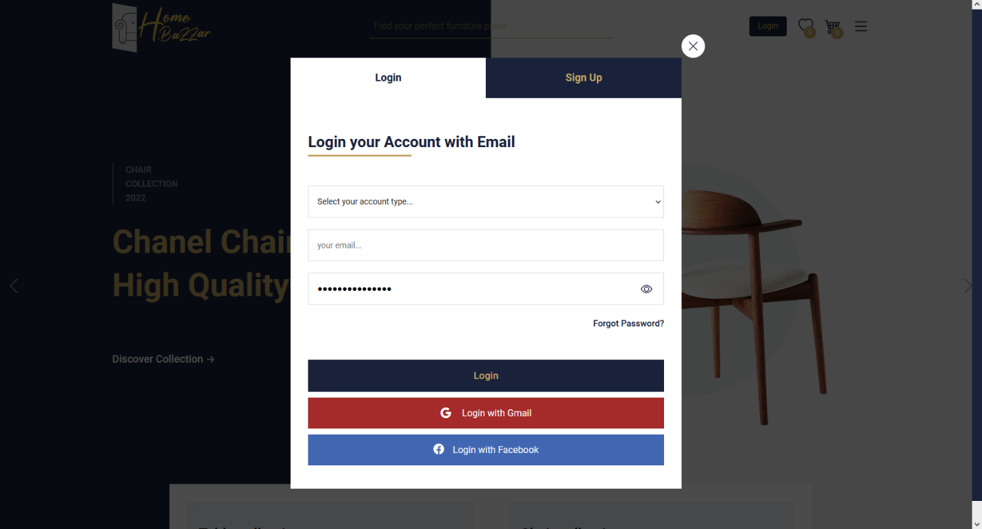

Product Video / Review / Related Products

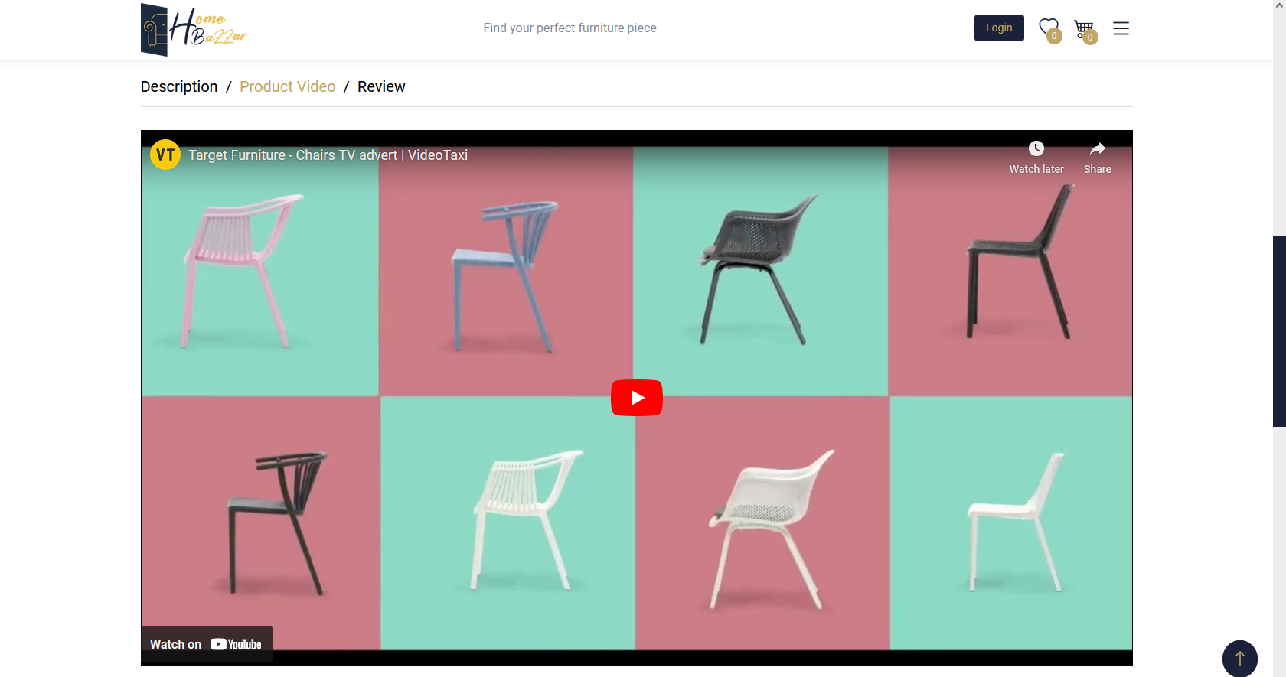

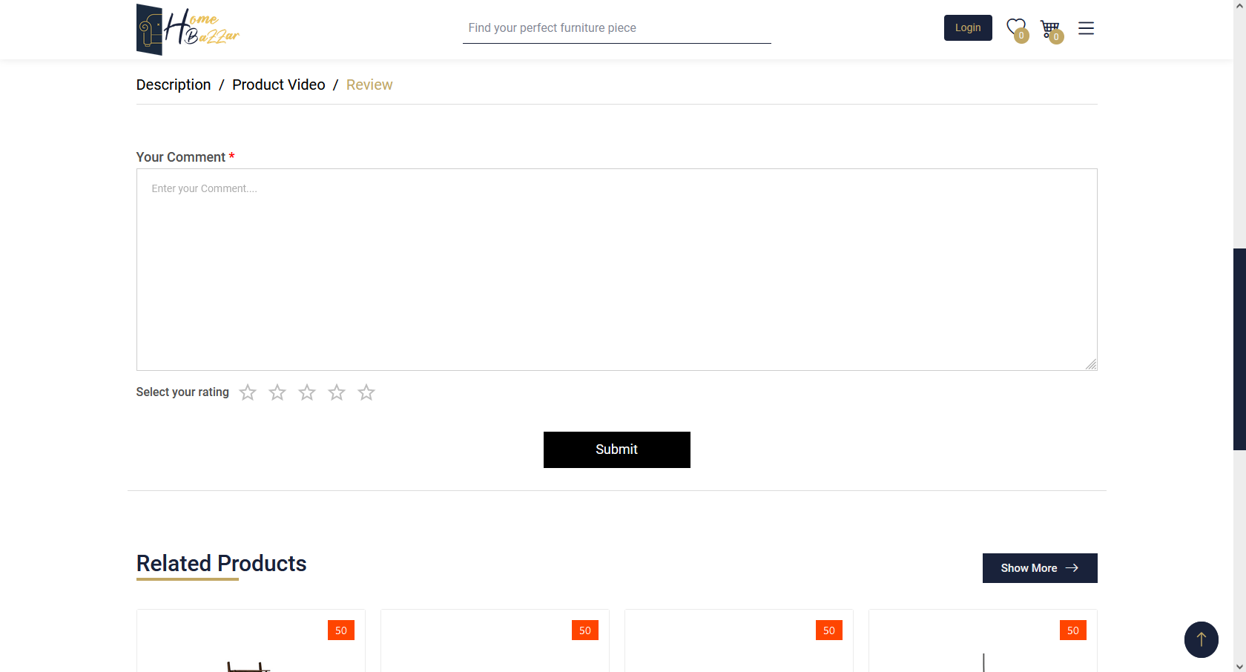

Email Verification:

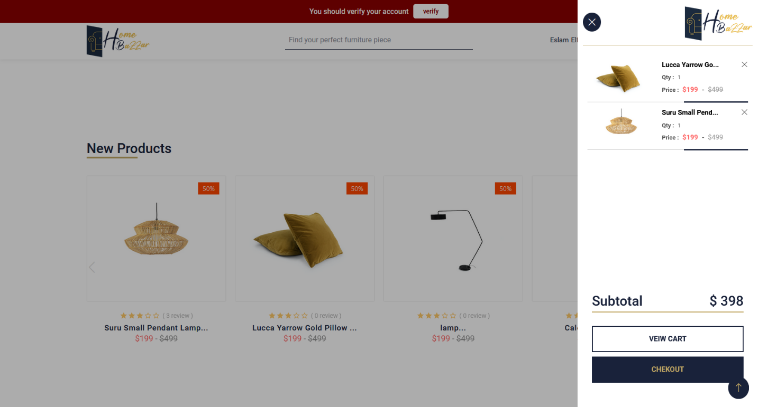

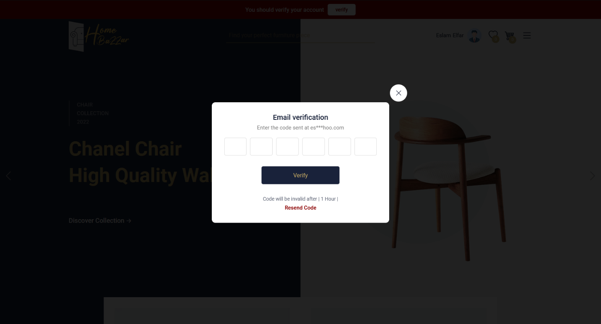

* 1. **Interface Design of the mobile application:**

The following sequence of Figures illustrates the interface design.

Figures 4.4.2 Interface Design of the mobile application.

**CHAPTER 6**

**Conclusion & Future Work**

**Conclusion:**

Our Furniture Online Store system is a comprehensive e-commerce solution that includes both a website and a mobile application. This system is structured around three primary categories: sellers, management, and clients. The website and application offer a user-friendly, intuitive interface that allows clients to browse and purchase furniture products with ease. The sellers' platform enables them to upload product information, manage inventory, and track orders. Meanwhile, the management platform provides administrators with tools for overseeing inventory, analyzing sales data, and managing the website and application. By combining these elements into a single, integrated system, the Furniture Online Store project aims to provide a seamless, end-to-end experience for all users.

**Future Work:**

**References:**